# Refresher Courses

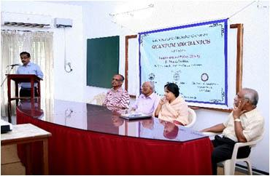

### Science Academis' Refresher Course on Quantum Mechanics-2014

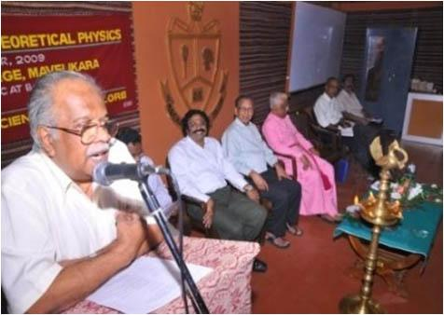

### Science Academie's Refresher Course in Theoretical Physics 2009