# National Conferences

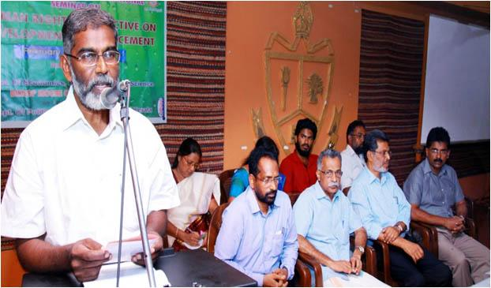

### Human Rights Perspective on Development & Displacement -2016 (Economics)

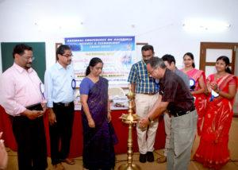

### Materials Science & Technology MSAT-2015 (Physics)

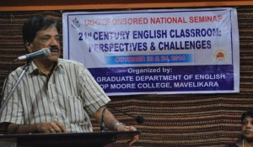

### 21st century English classroom perspectives & challenges-2014 (English)

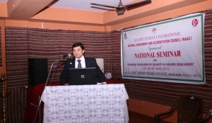

### Emerging Trends of Quality in Higher Education-2013 (IQAC)

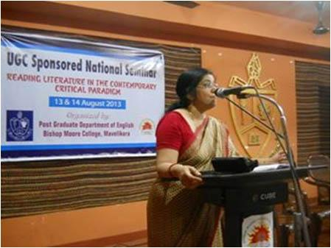

### Reading Literature in the Contemporary Critical Paradigm-2013 (English)

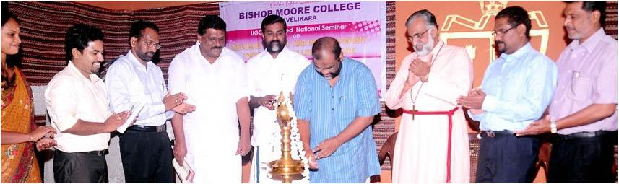

### Inclusive Growth and Indian Economy-Twenty Years of Liberalisation (Economics)-2012

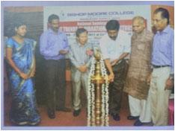

### Recent Trends in Vibrational Spectroscopy, RTVS-2011 (Physics)

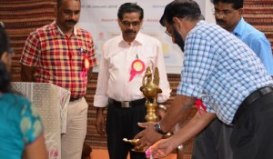

### Experimental & Theoritical Approach to Photonics, ETAP-2016 (Physics)

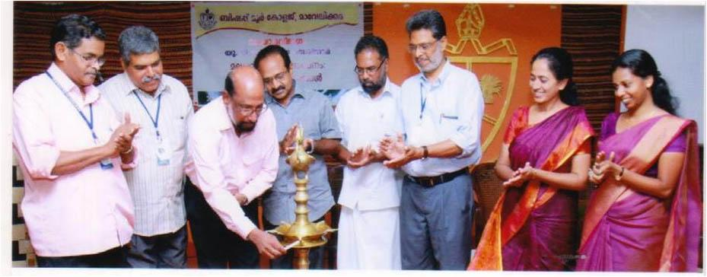

### Malayala Vyakarana Padanam: Vyathyastha Sameepanangal-2015 (Malayalam)

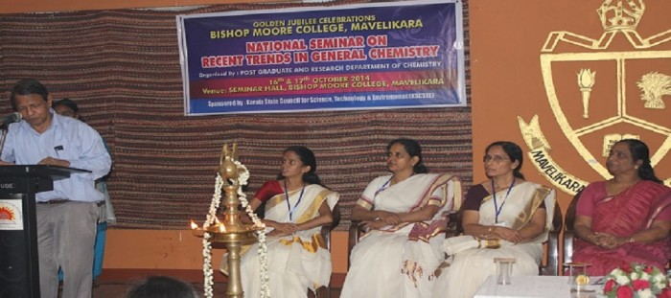

### General Trends in Chemistry-2014 (Chemistry)

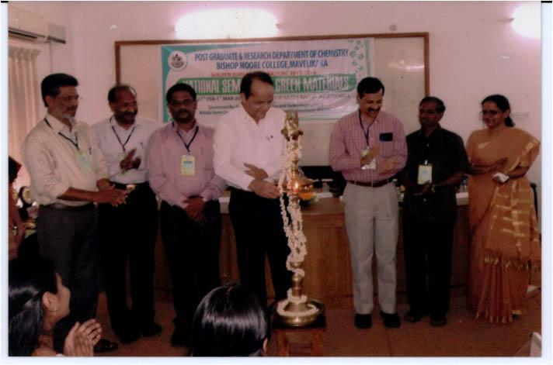

### National Seminar on Green Materials-2013 (Chemistry)

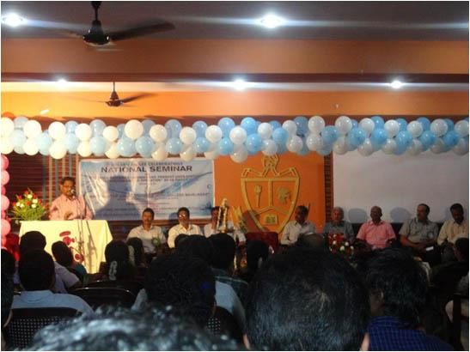

### Water Resource Management: Present Uses, Status, Conservation and Co-operation-2013 (Zoology)

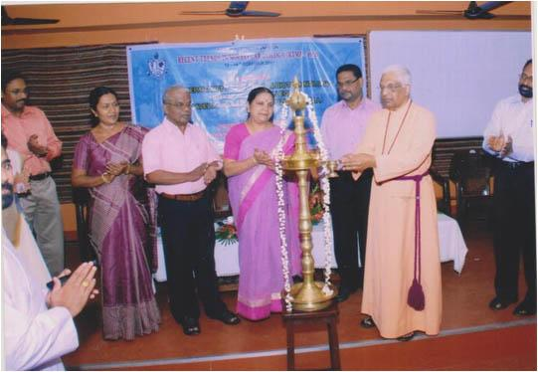

### Recent Trends in Molecular Biology RTMB-2012 (Botany & Biotech)