# International Conferences

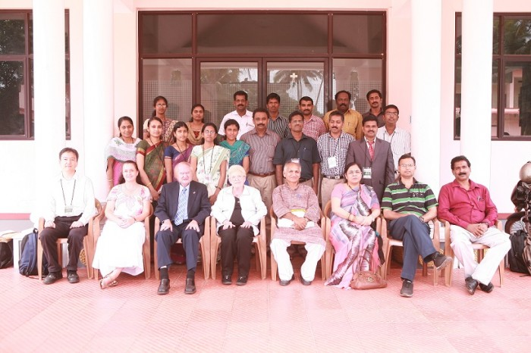

### ICOPVS 2013 team

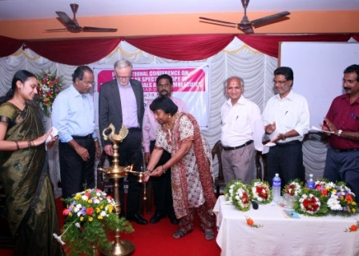

### International Conference on Materials Science & Advanced Biomolecules, IMSAB-2012

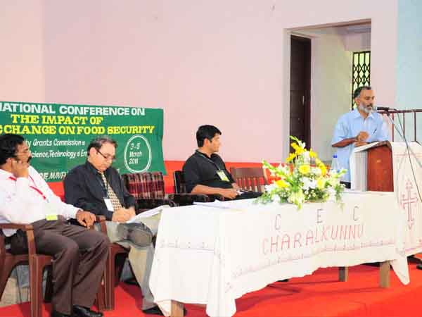

### International Conference on Climate Change & Food Security: 3-5 March 2011

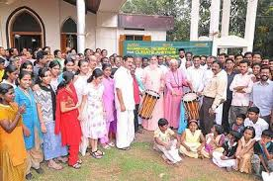

### International Conference on Climate Change & Food Security: 3-5 March 2011

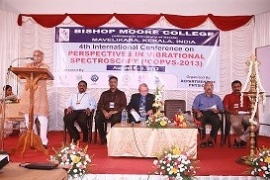

### International Conference on perspectives in Vibrational Spectroscopy, ICOPVS-2013

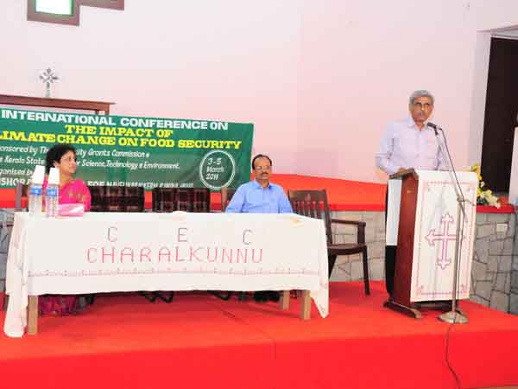

### International Conference on Climate Change & Food Security: 3-5 March 2011

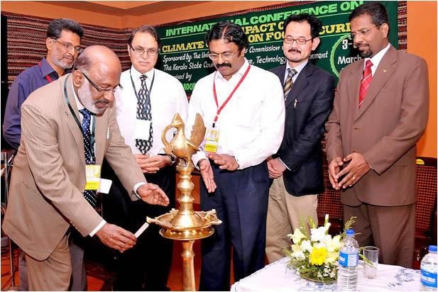

### International Conference on Climate Change & Food Security: 3-5 March 2011

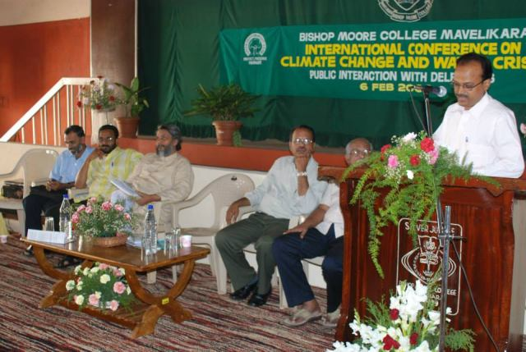

### International Conference on Climate Change & Water Crisis : 6 Feb 2008