Vimukthi Mission 2018: 1 March 2018

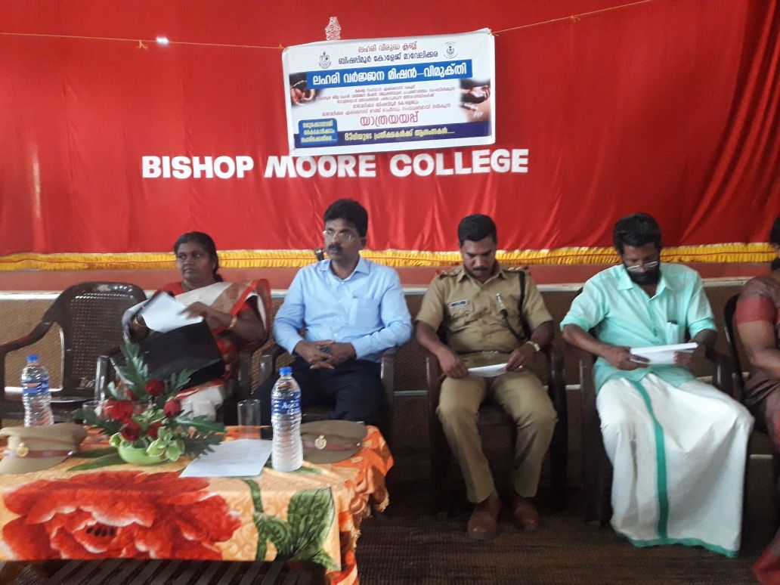





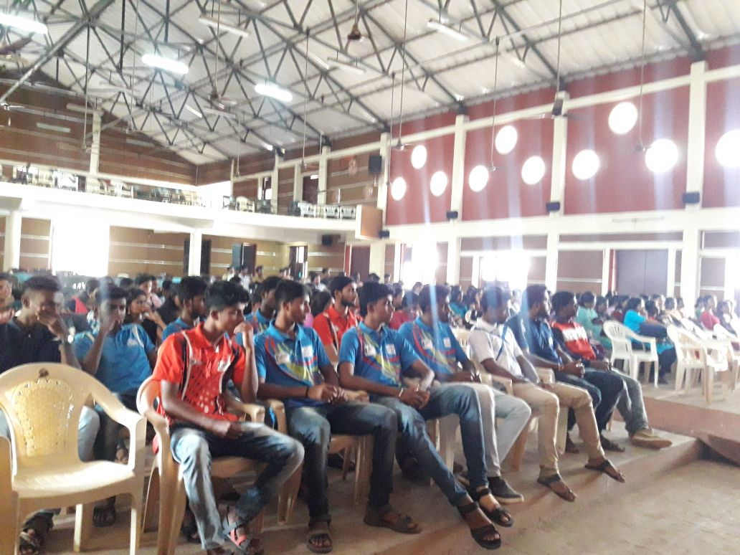

### Postal Address

Dr. Jacob Chandy

Principal, Bishop Moore College

Mavelikara. Pin: 690110