Invited Lecture on “Life Skill Development”: 9 Aug 2017

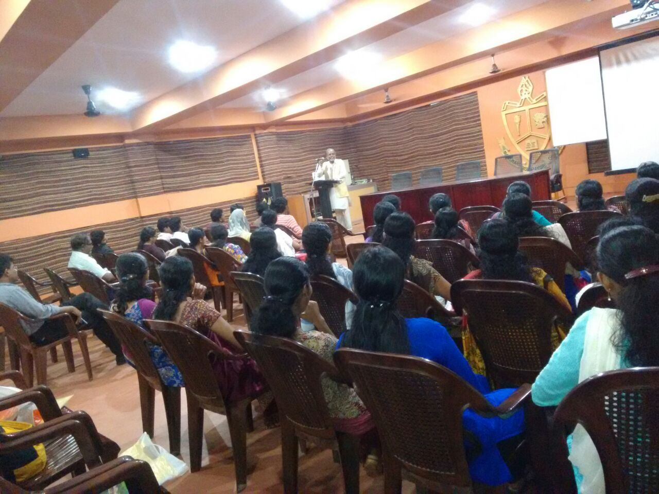

Dr. R. Sethumadhavan speaking on topic "Life Skill development through a Holistic Approach"

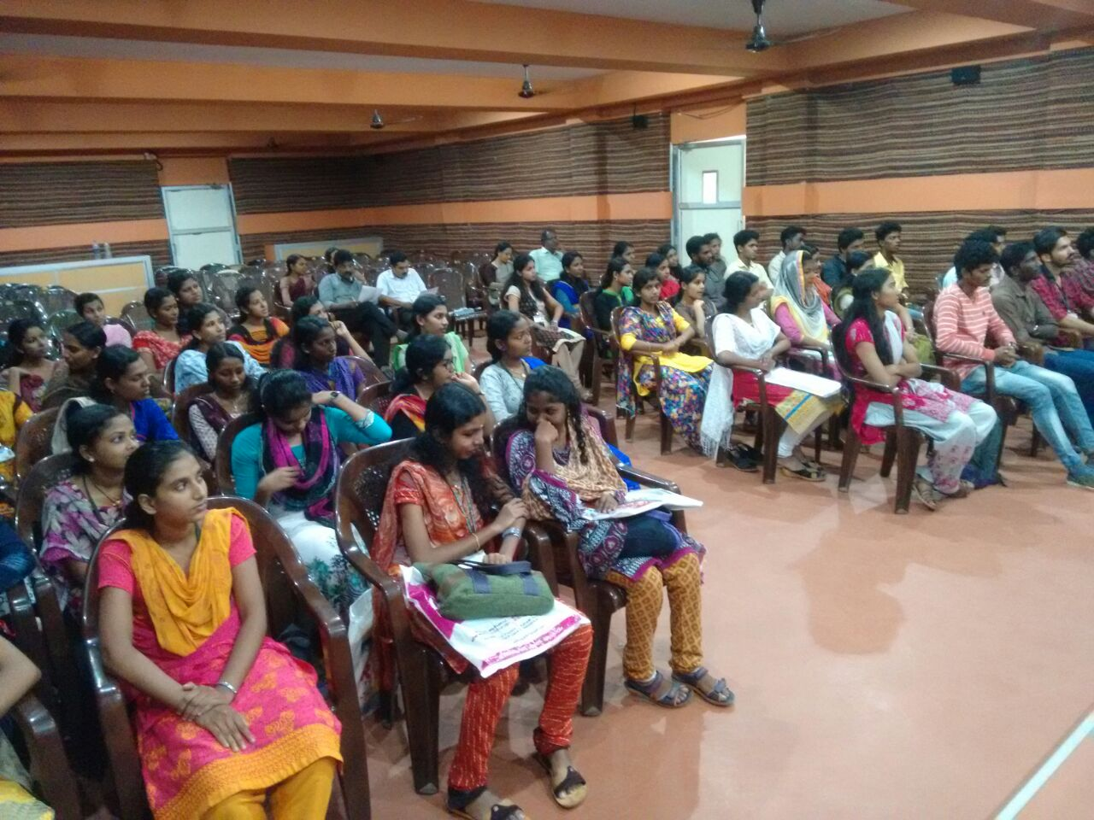

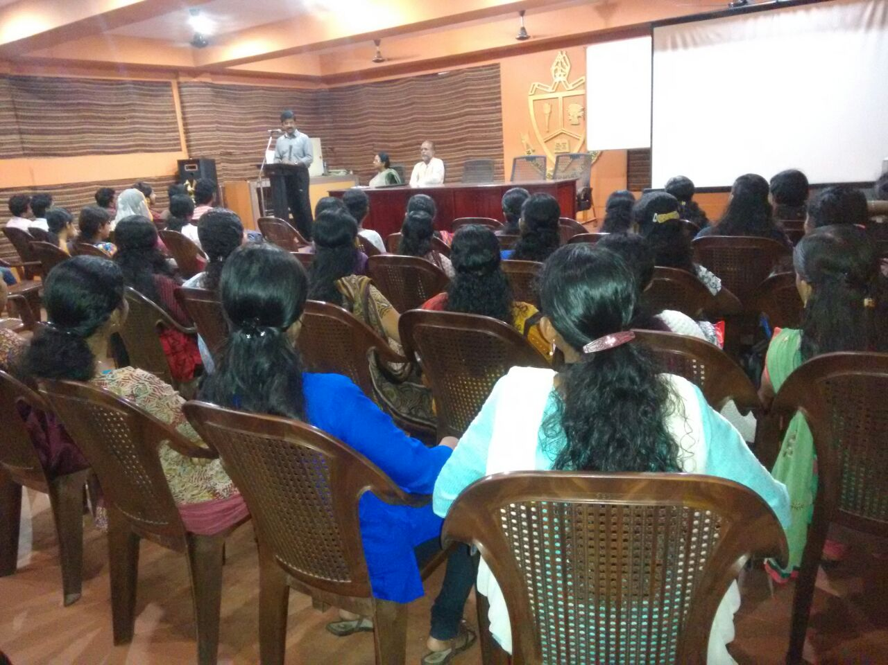

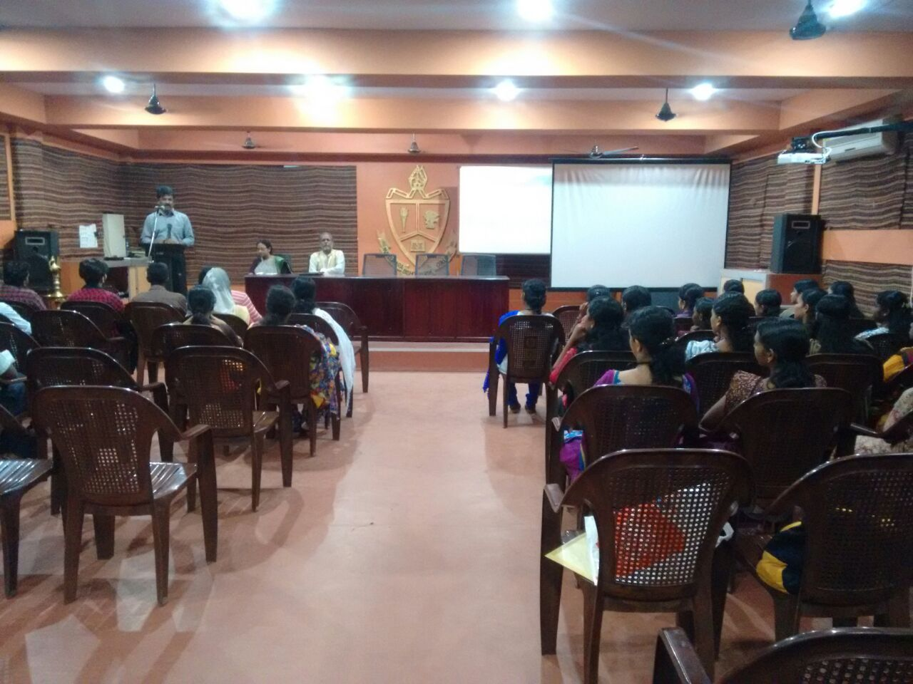

### Postal Add