Student Support: 14 June 2017

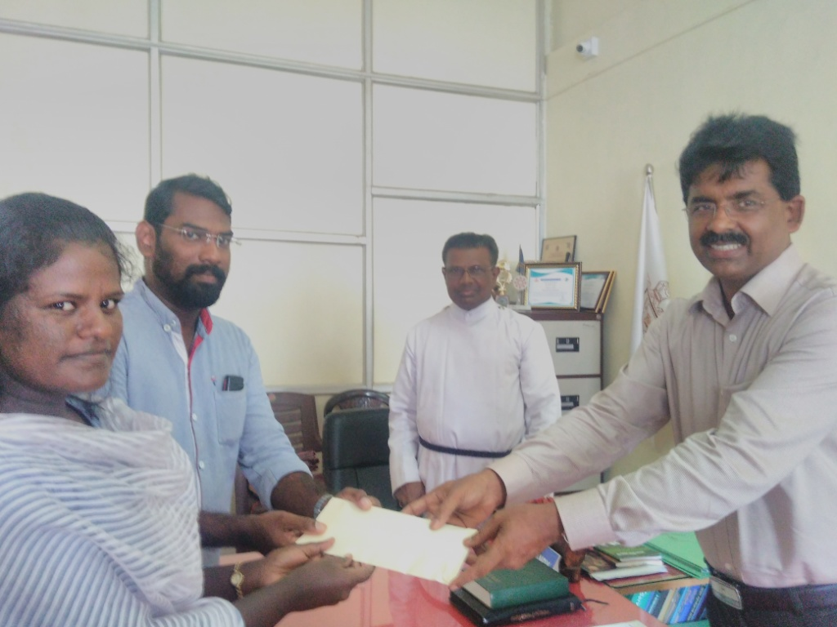

Dr. Jacob Chandy, Principal of the college, hand overs contribution towards marriage expenses, collected from teaching staff, to Revathy, student of Botany & Biotechnology Department

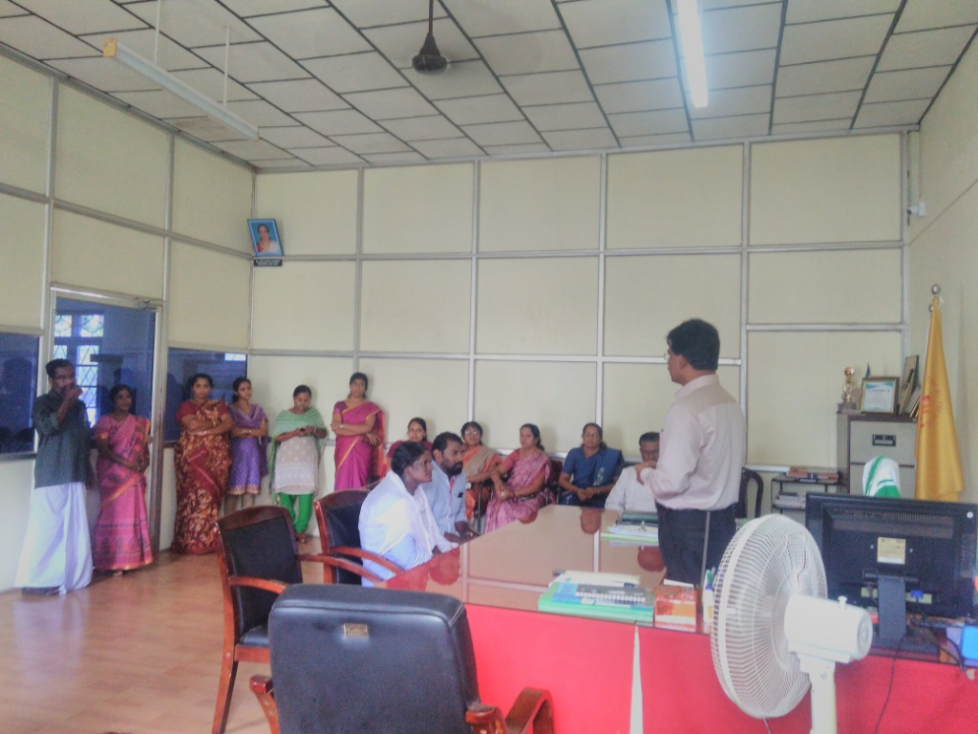

### Postal Address

Dr. Jacob Chandy

Principal, Bishop Moore College

Mavelikara. Pin: 690110

Kerala.

Mail Id: bpmoorecollege@gmail.com

### Contact Details

Principal : 04792303230

Office :04792303260

Mail Id: bpmoorecollege@gmail.com

### Locate Us

Copyrights © 2016, Bishopmoore College. All Right Reserved.

Website Designed, Developed and maintained by [Pragmachs Digital](http://www.pragmachs.com/)

* [F](https://www.facebook.com/bpmoorecollege)