Staff Retreat led by Dr. Valsan Thampu: 05 June 2017

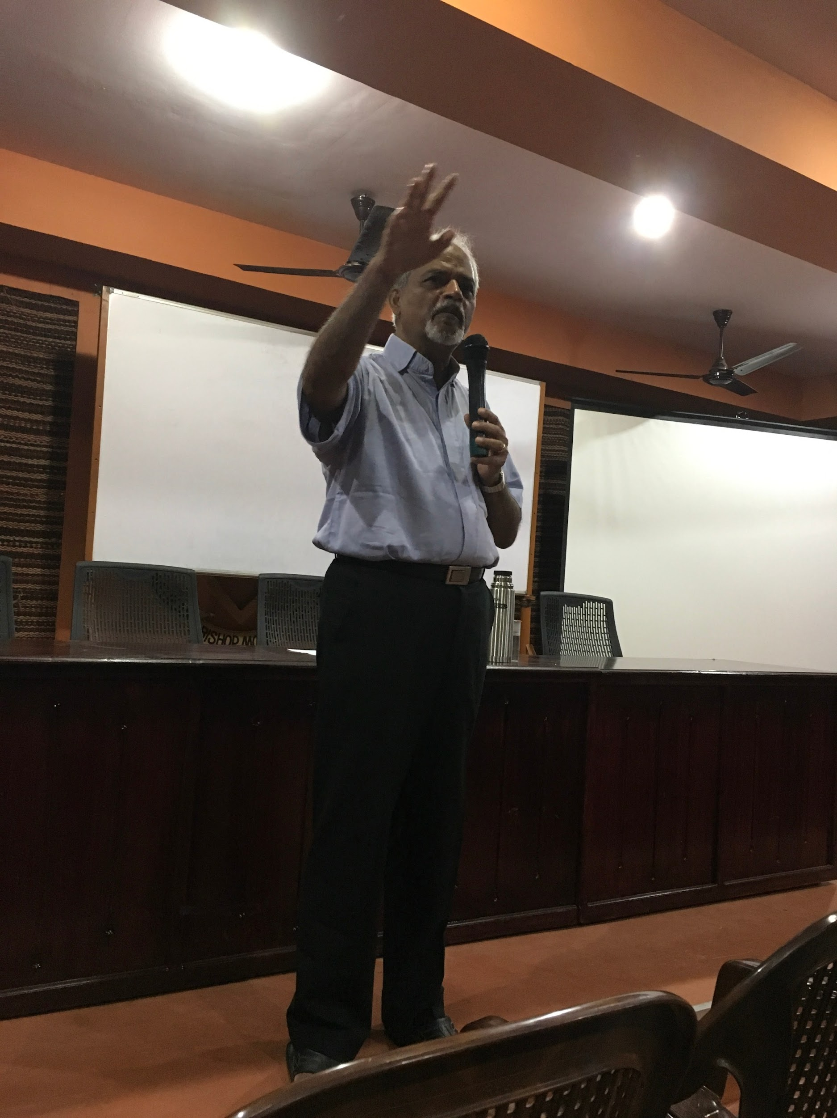

Dr. Valsan Thampu, former Principal of St. Stephen's College, New Delhi & alumnus of the college

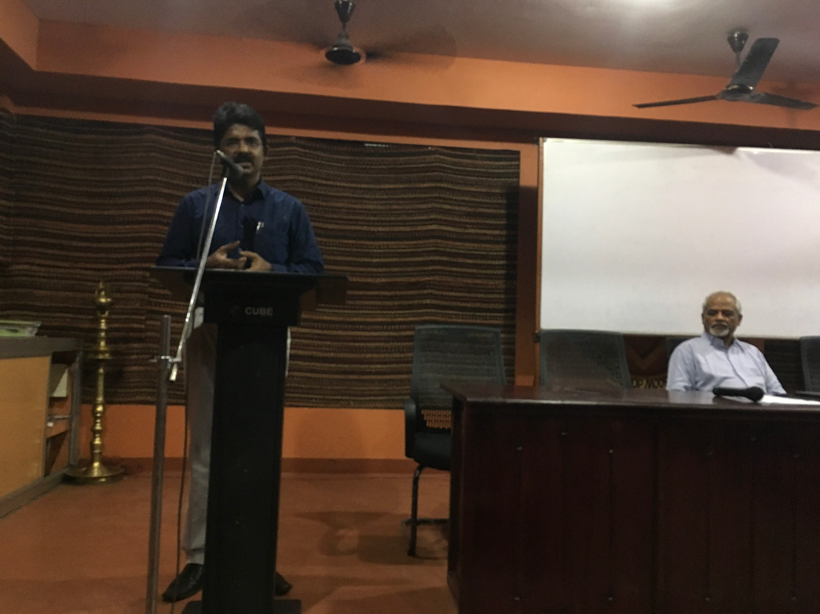

Welcome speech: Dr. Jacob Chandy

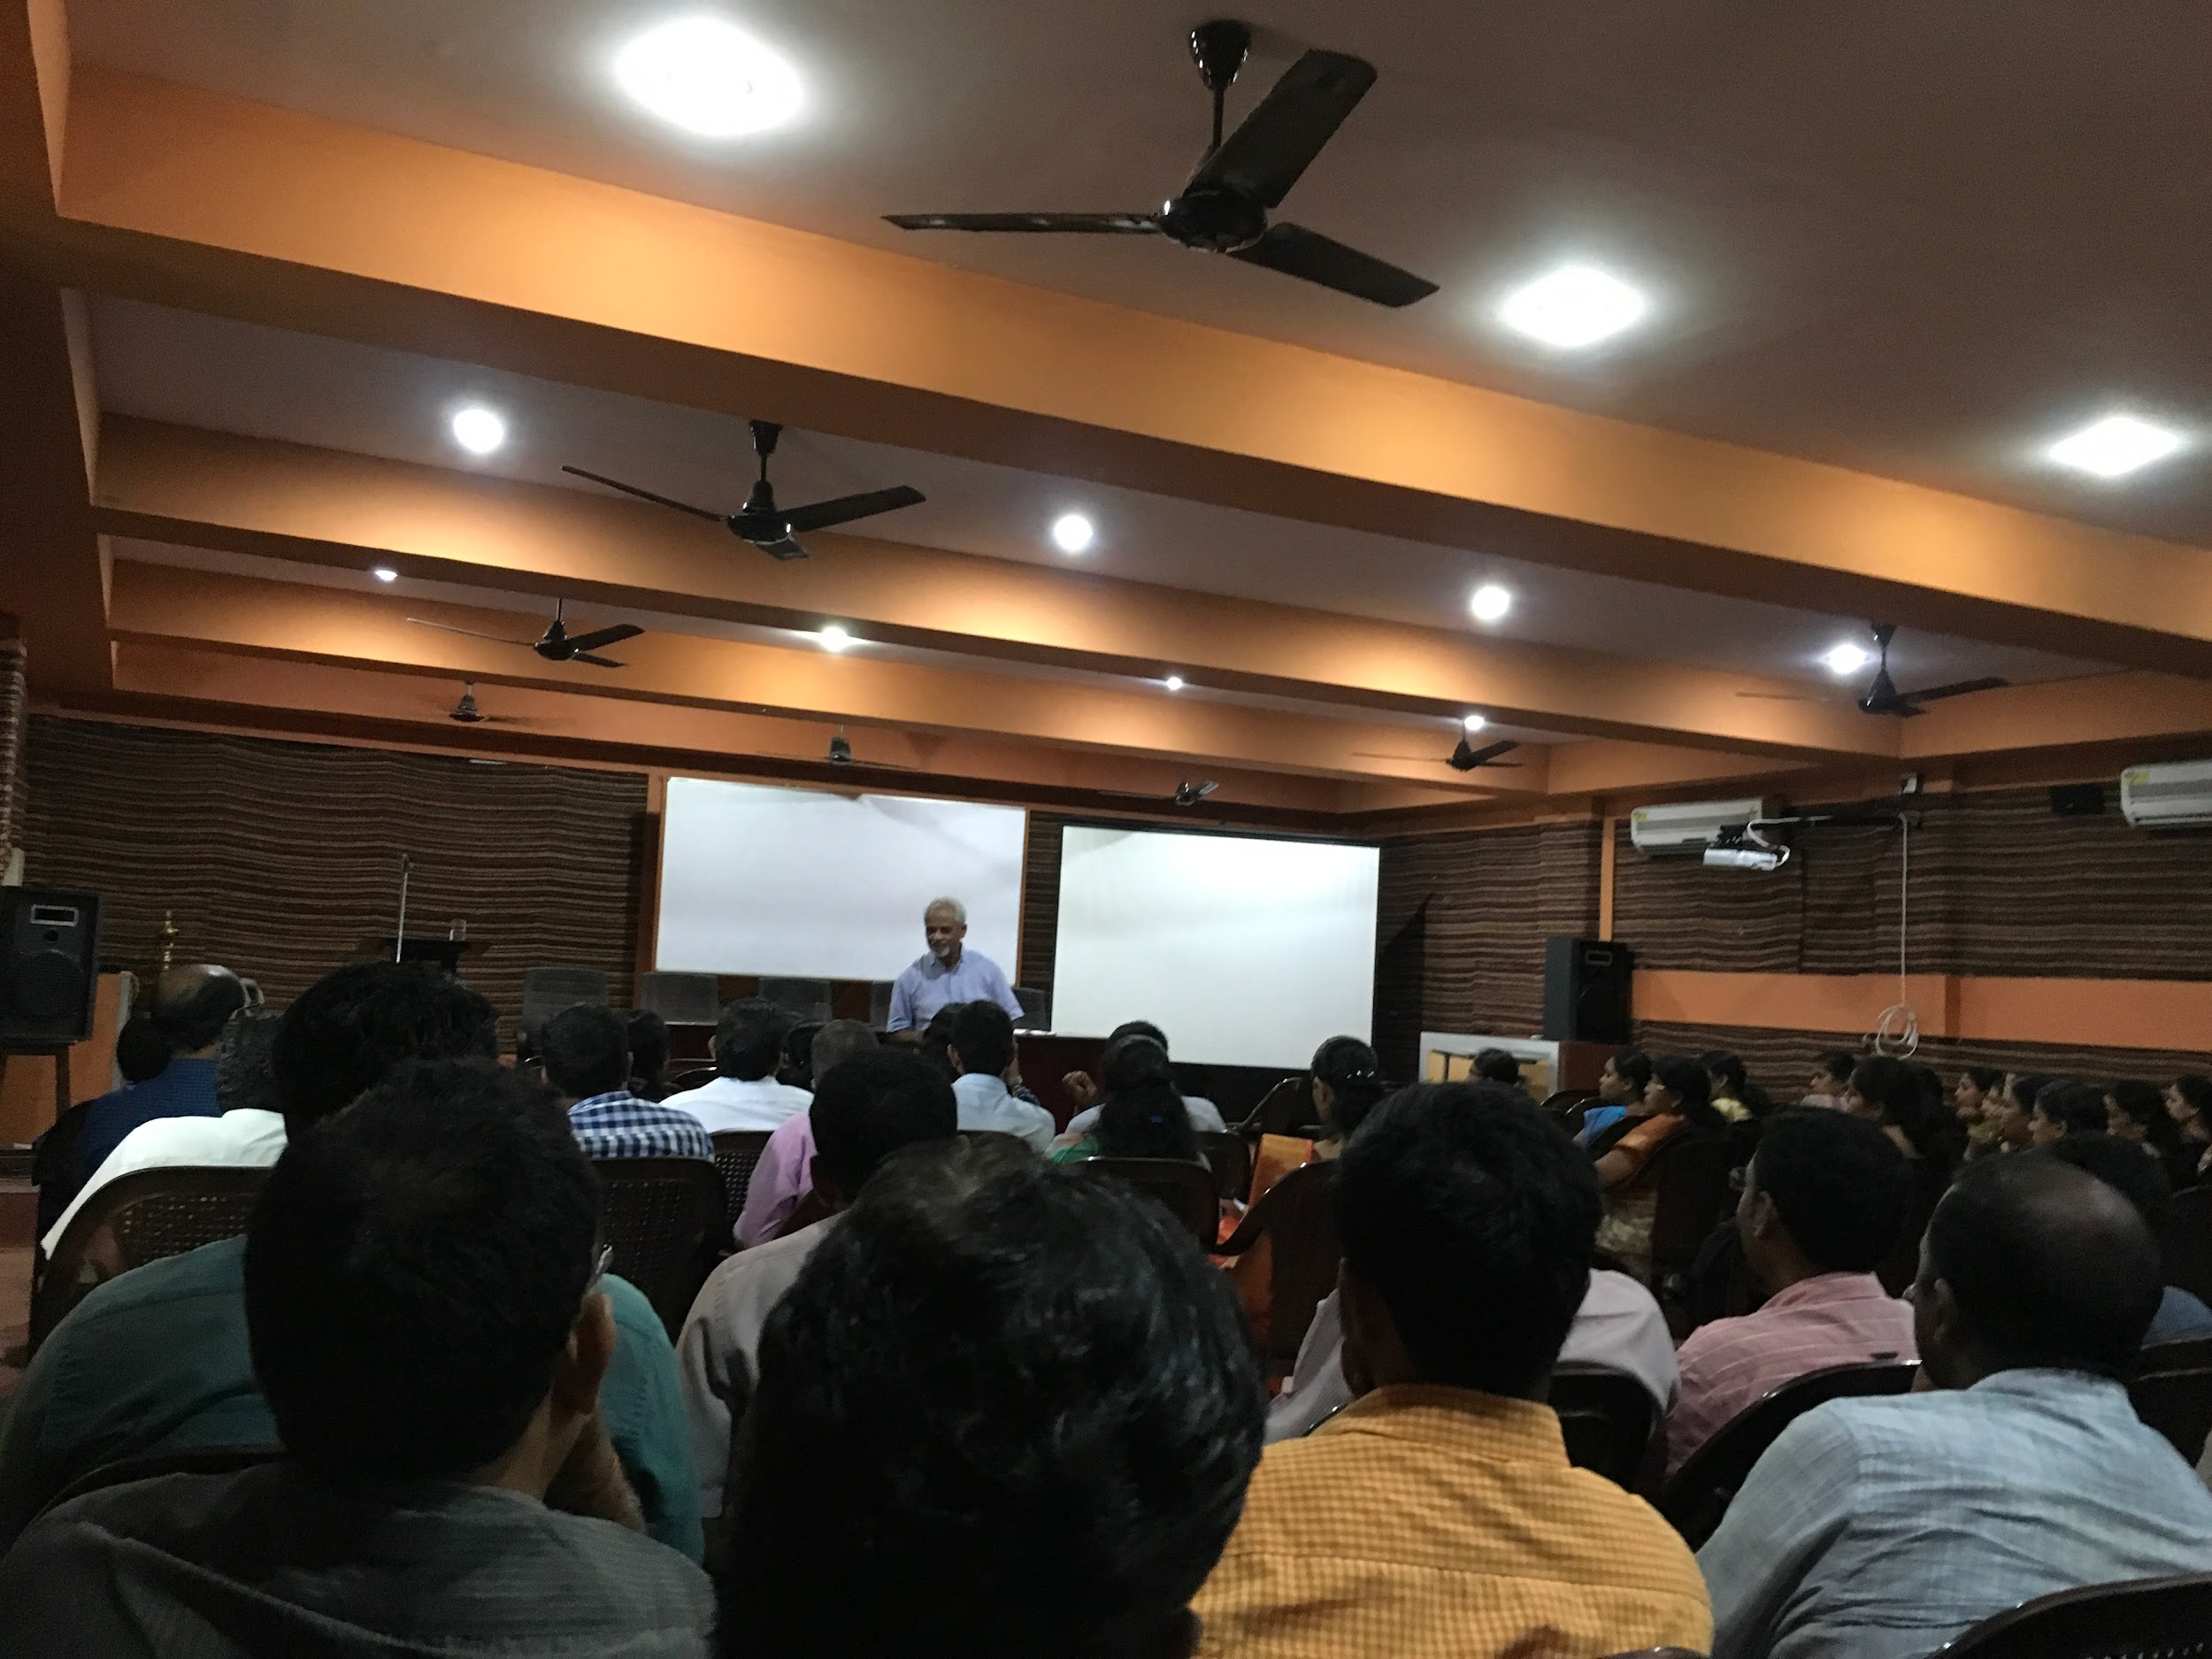

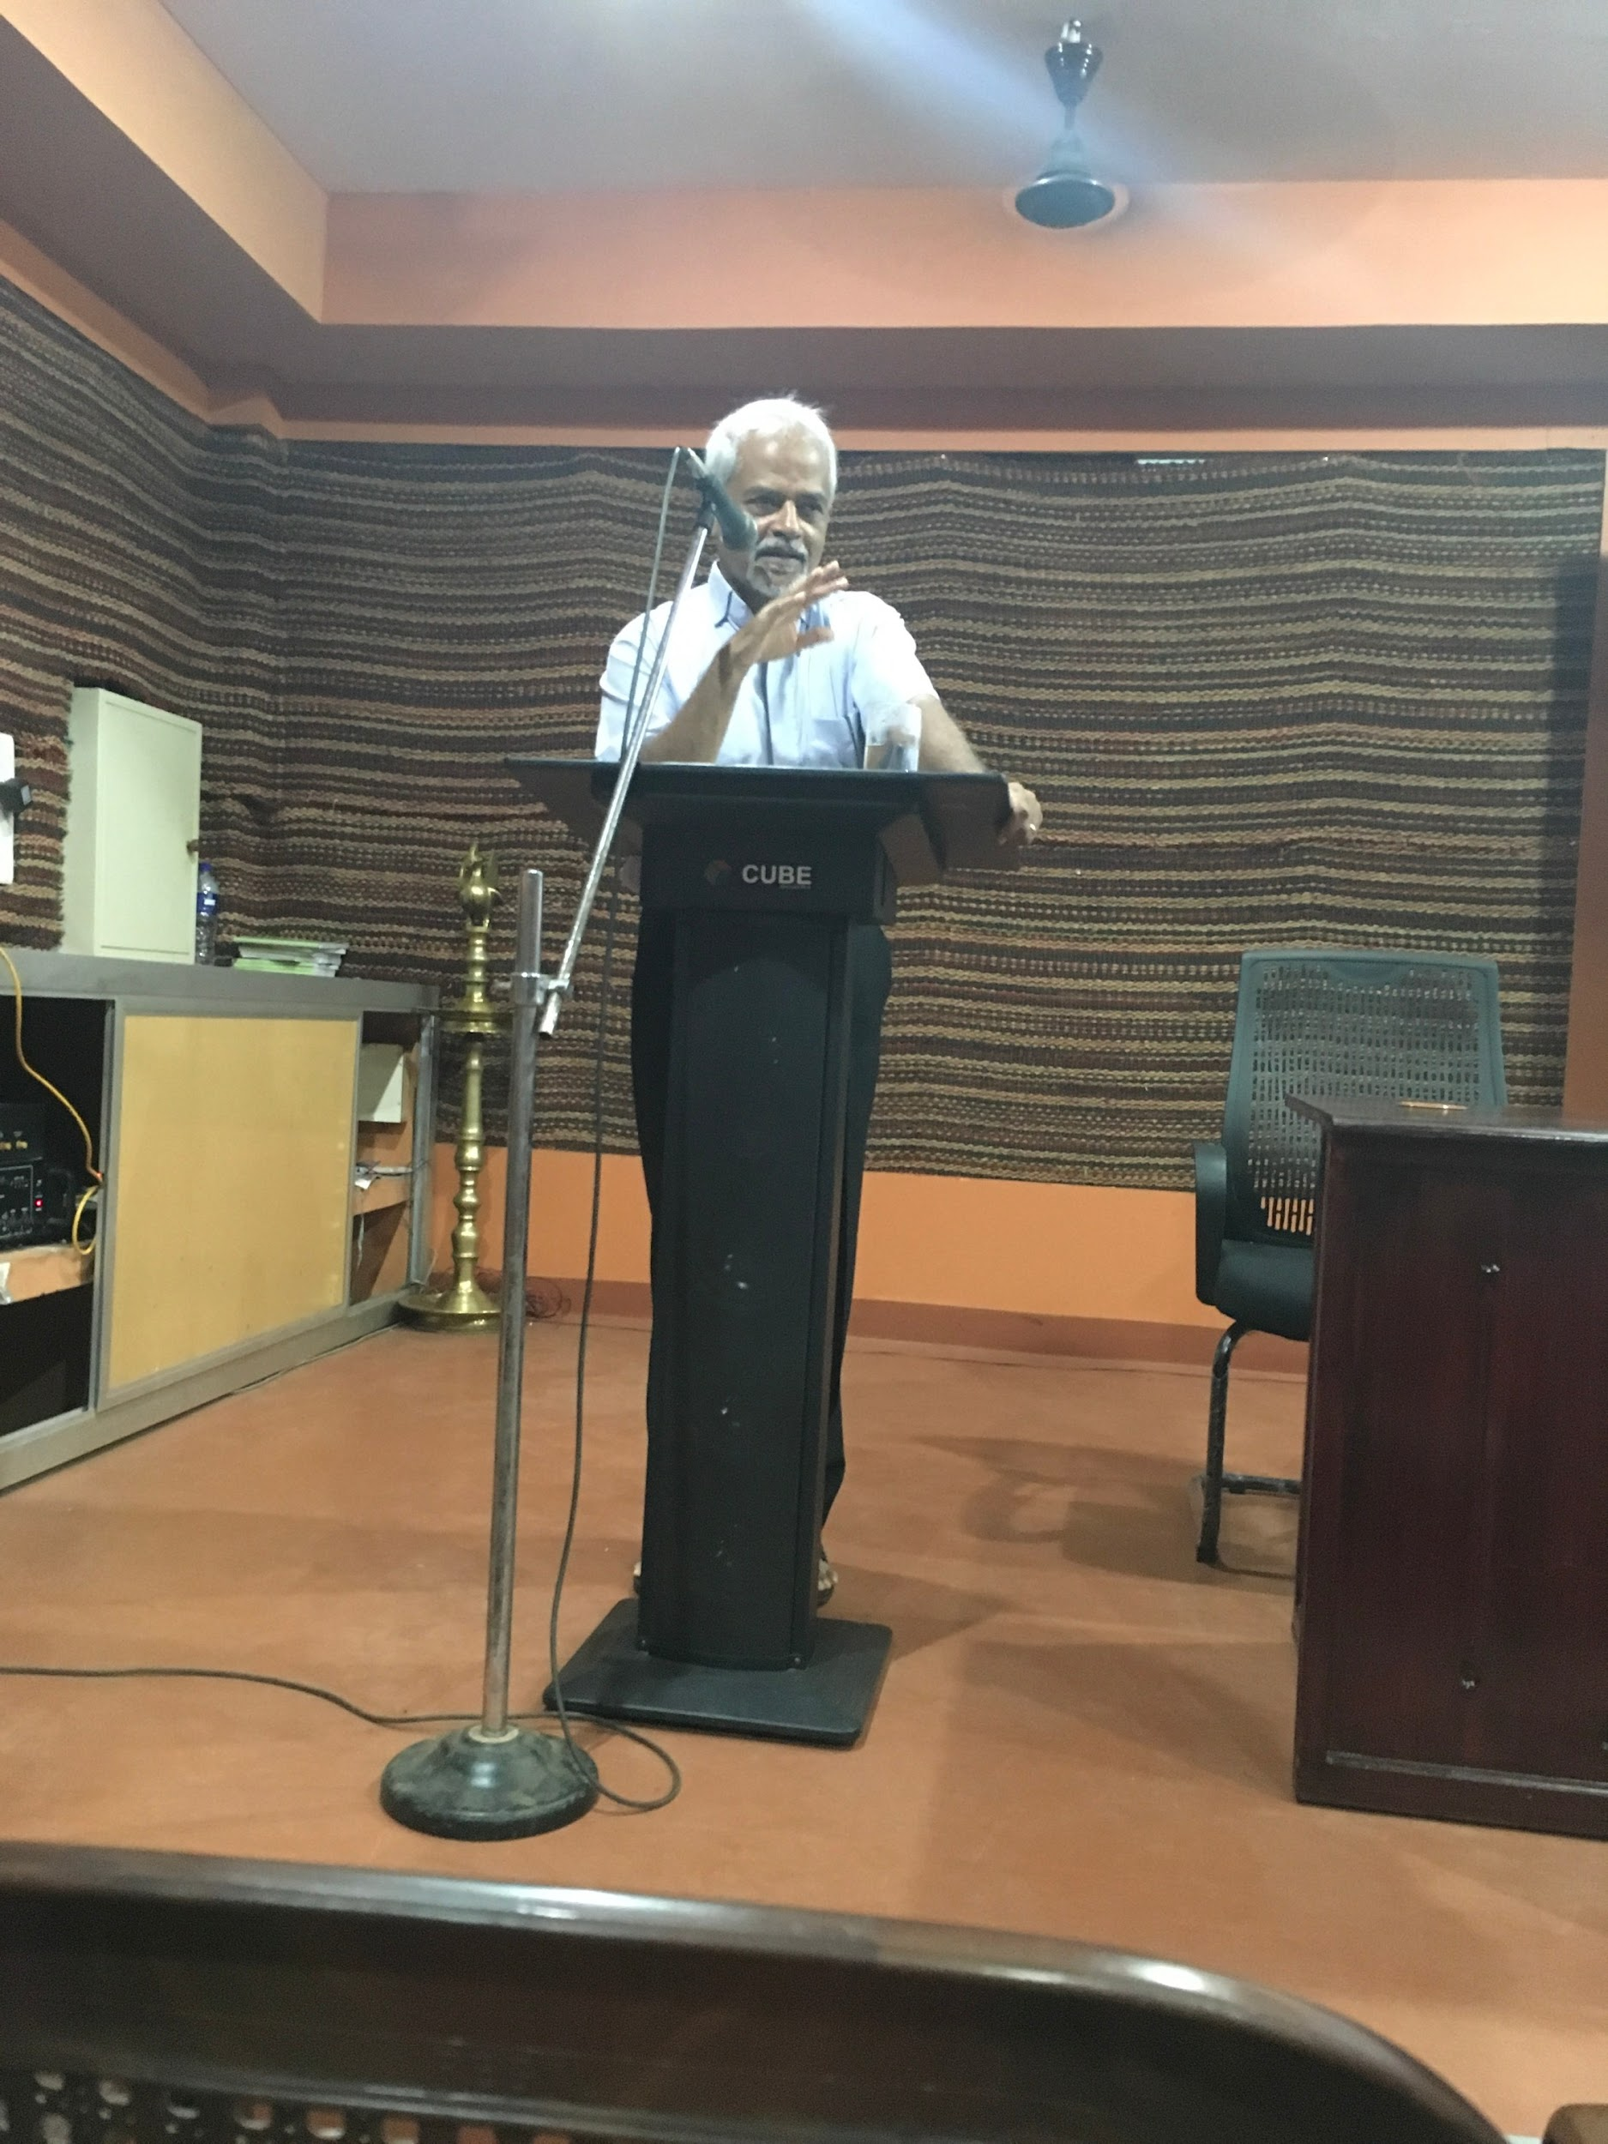

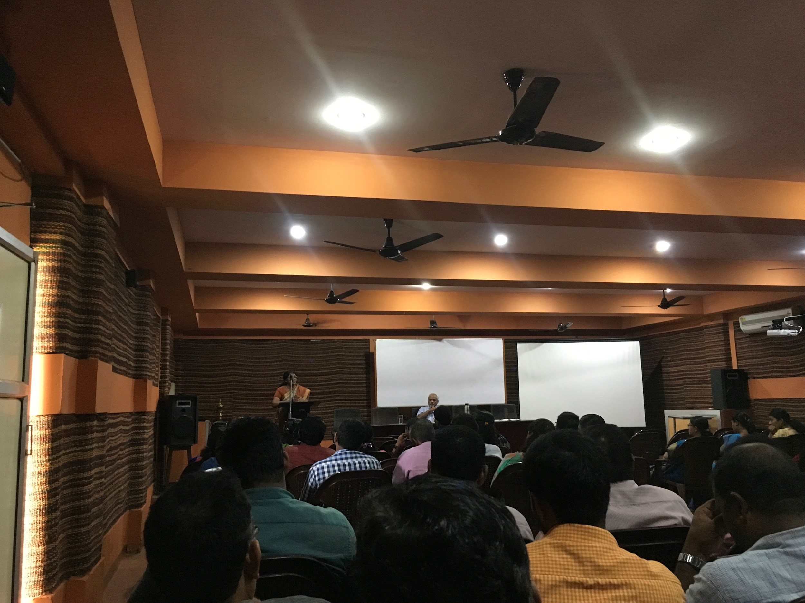

Vote of thanks: Prof. Giggy P. Koshy

### Postal Address