Refresher Course in Experimental Physics: 13-28 Sep 2017
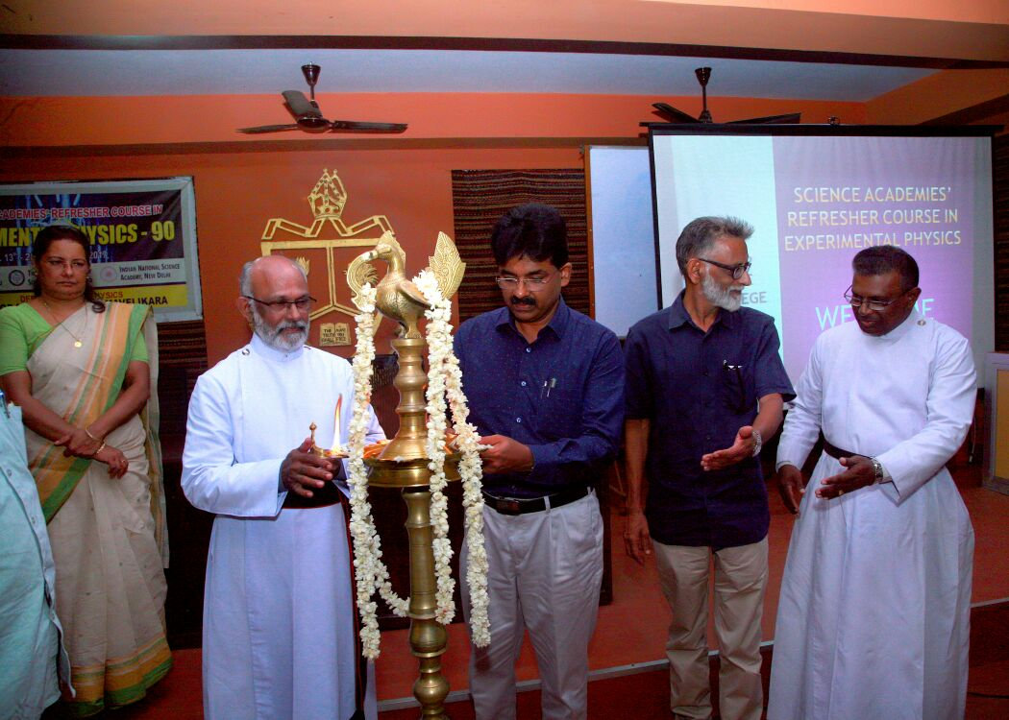
Inauguration by Very. Rev. Daniel George, CSI Madhya Kerala Diocese Administrator
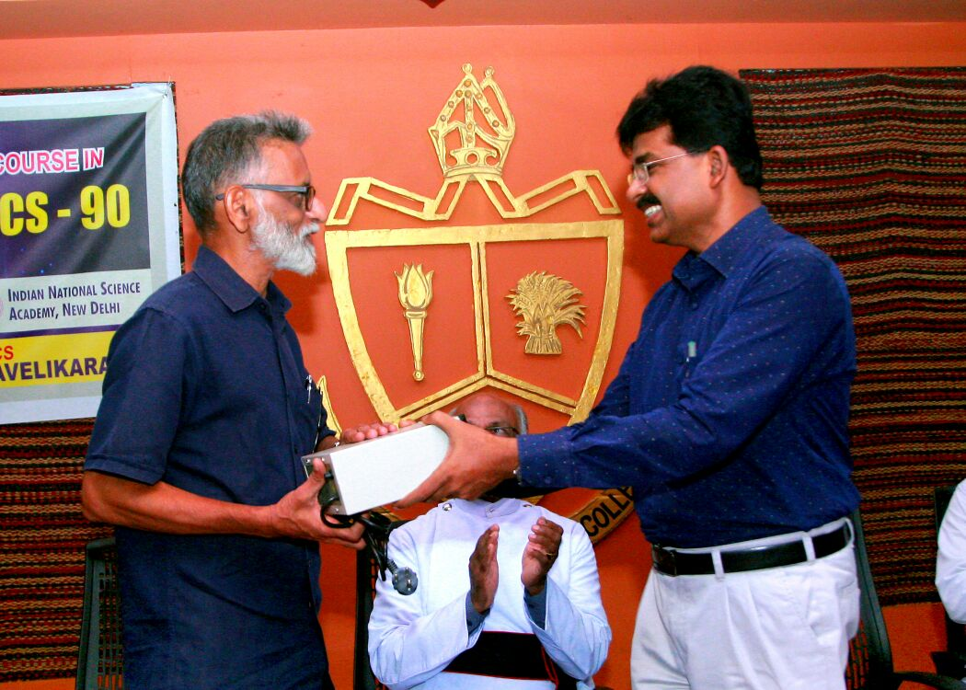
Dr. C S Sundar hands over instruments worth 1.5 lakhs to Principal
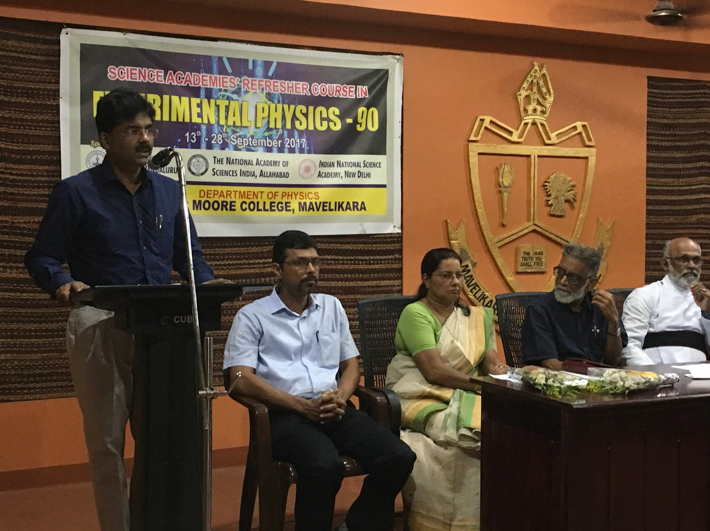
Inaugural Fn, Presidential Address: Dr. Jacob Chandy
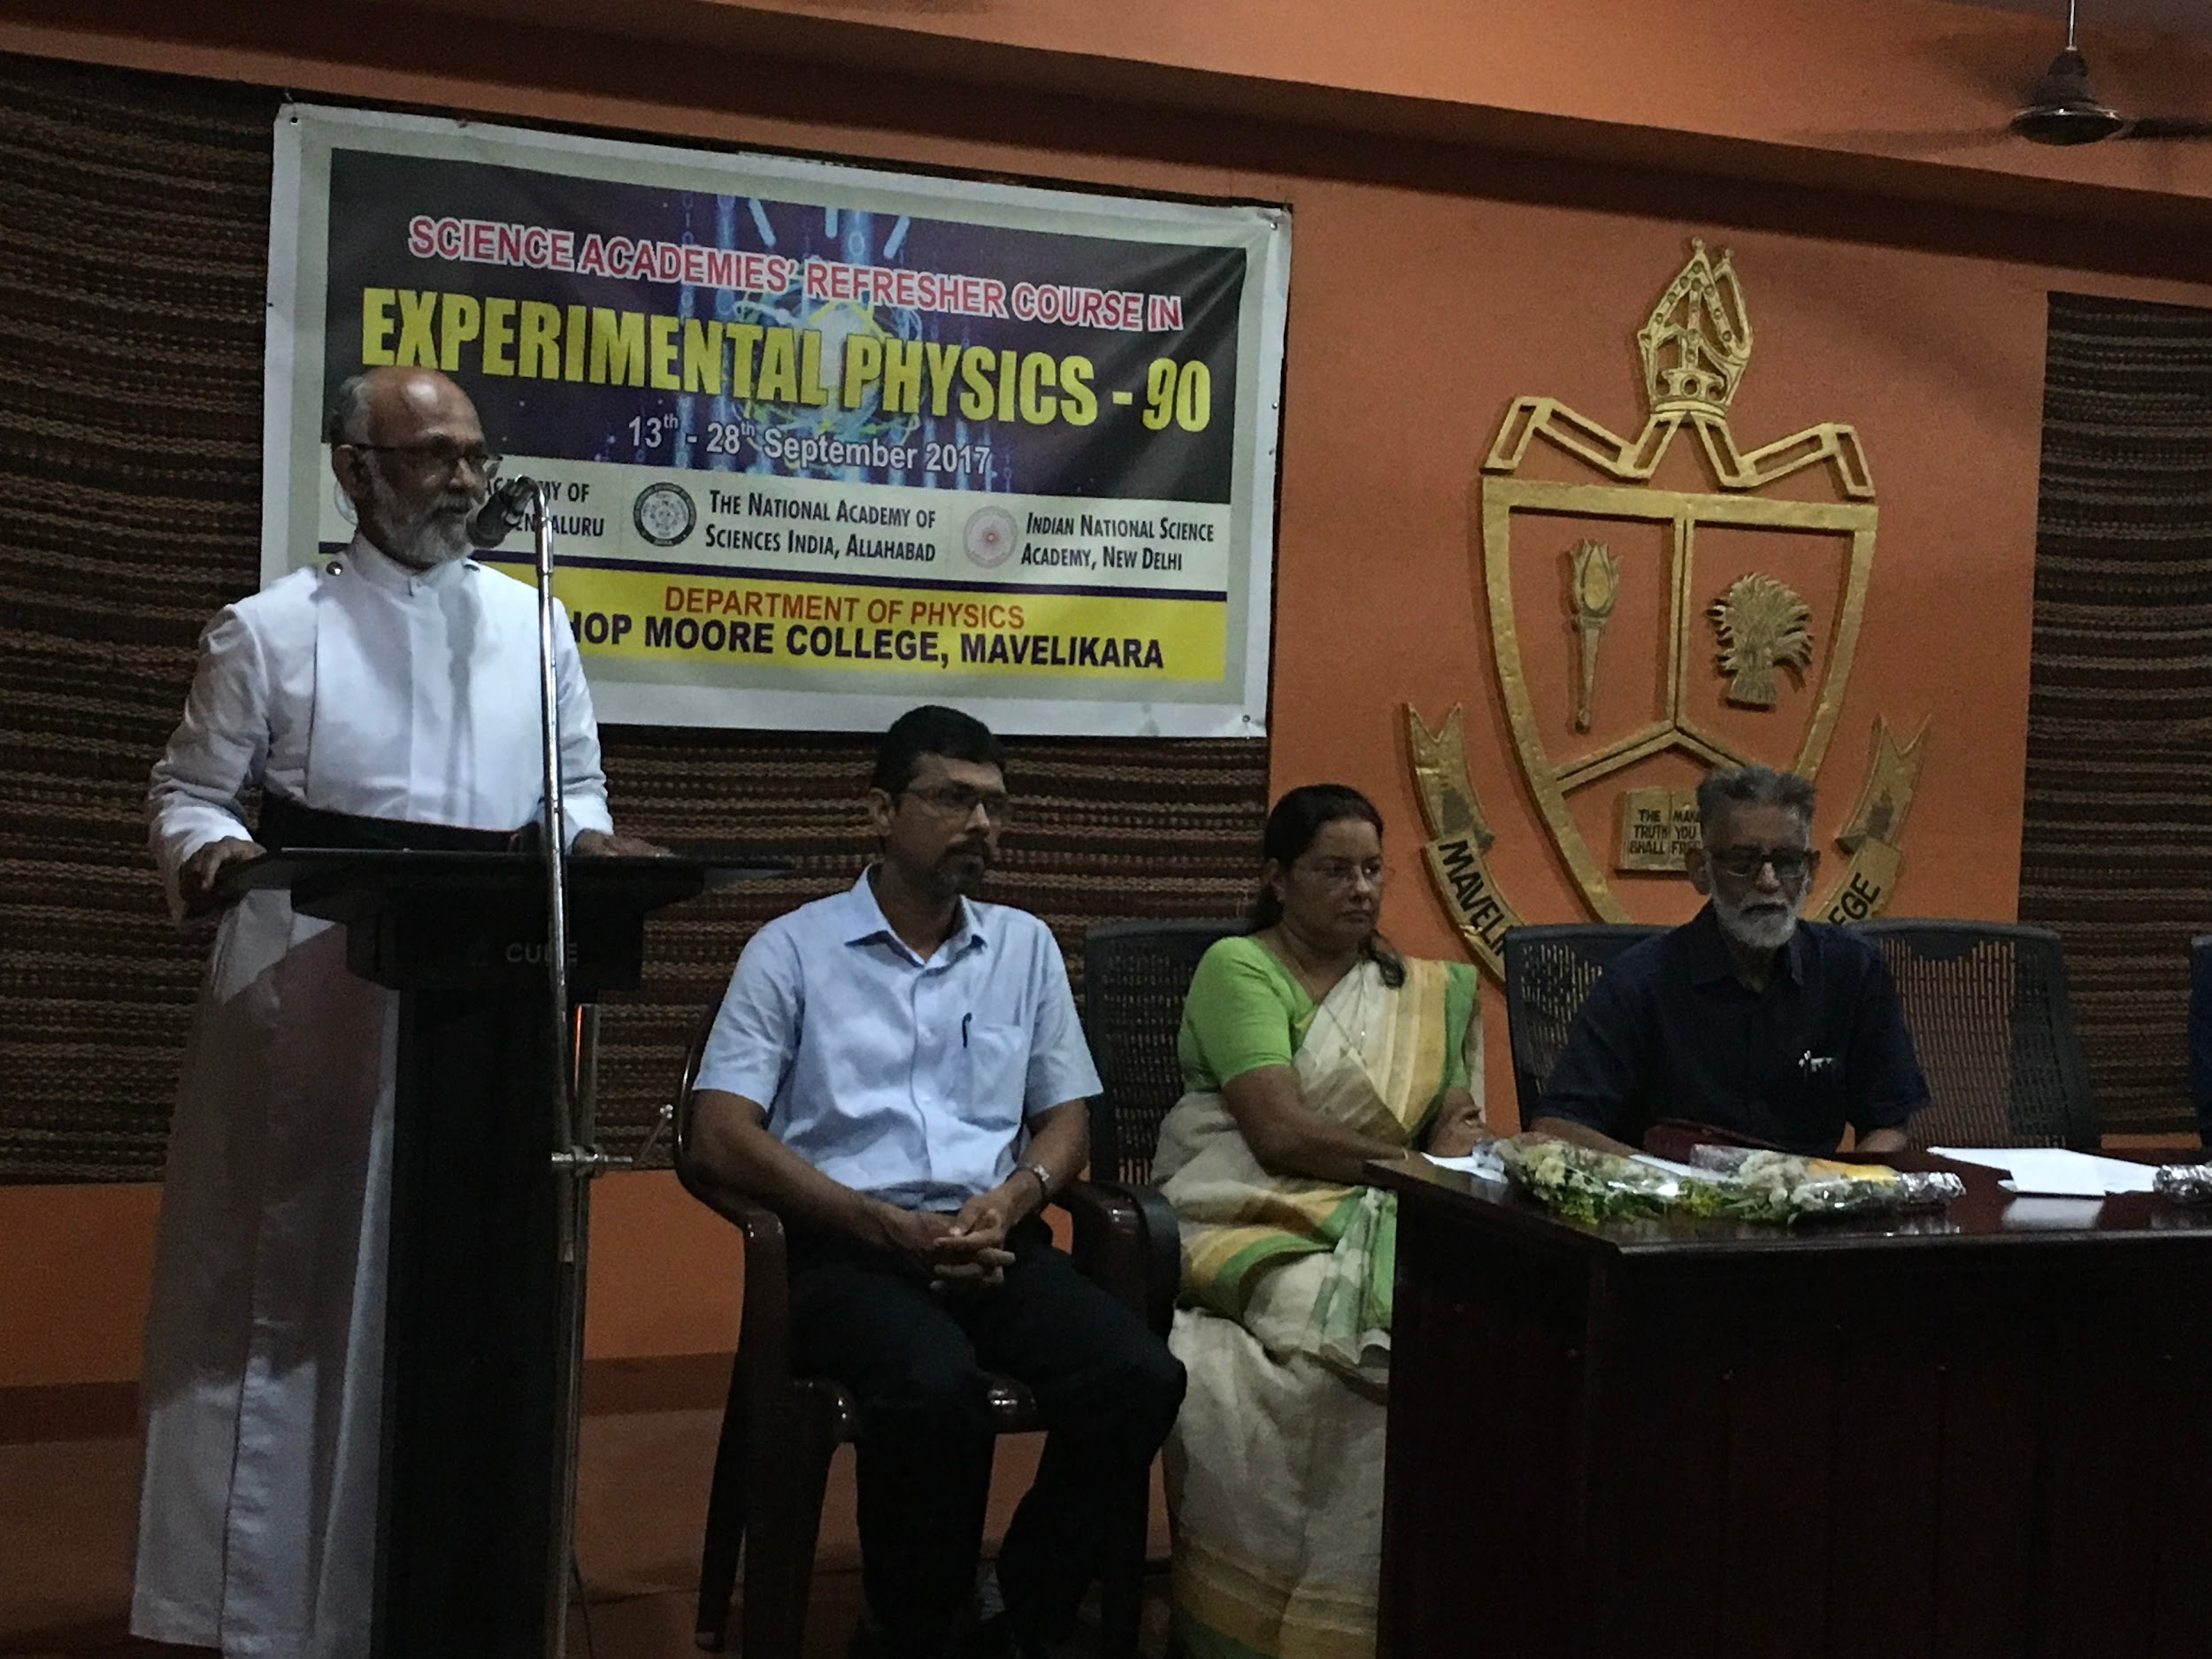
Inaugural Address: Very Rev. Daniel George
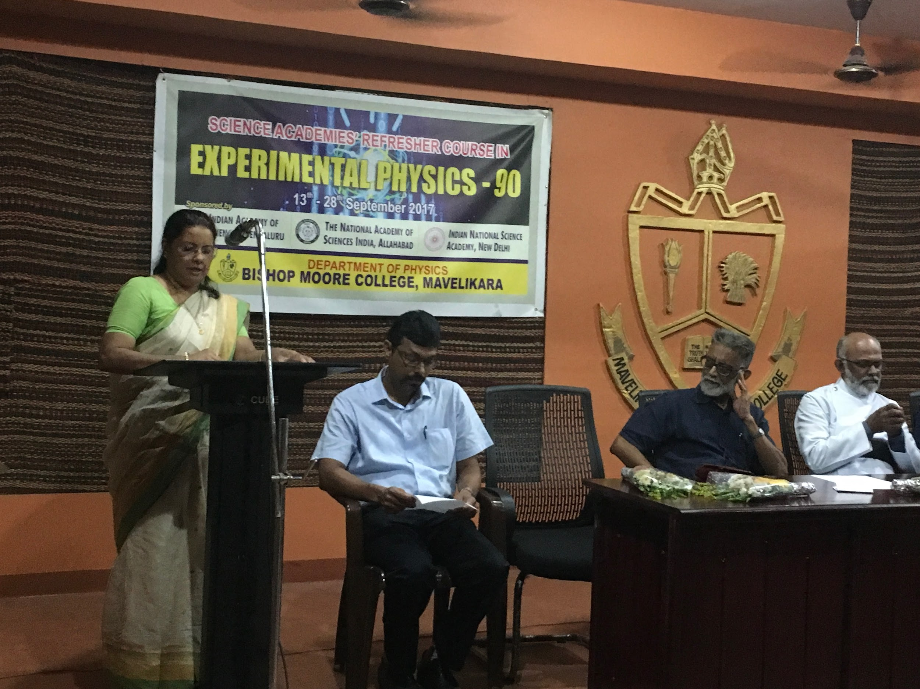
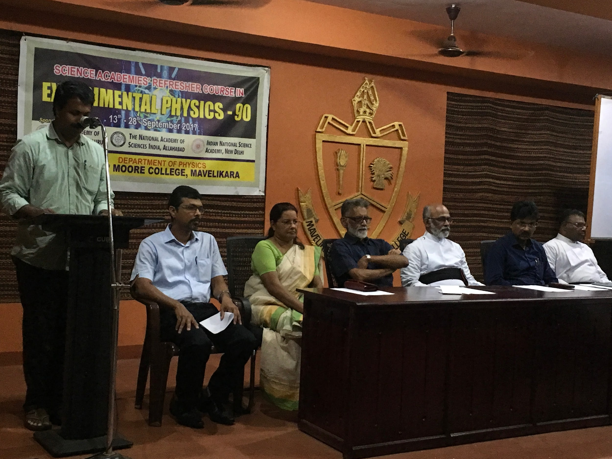
Inaugural function Welcome speech: Prof. Javeesh Alex
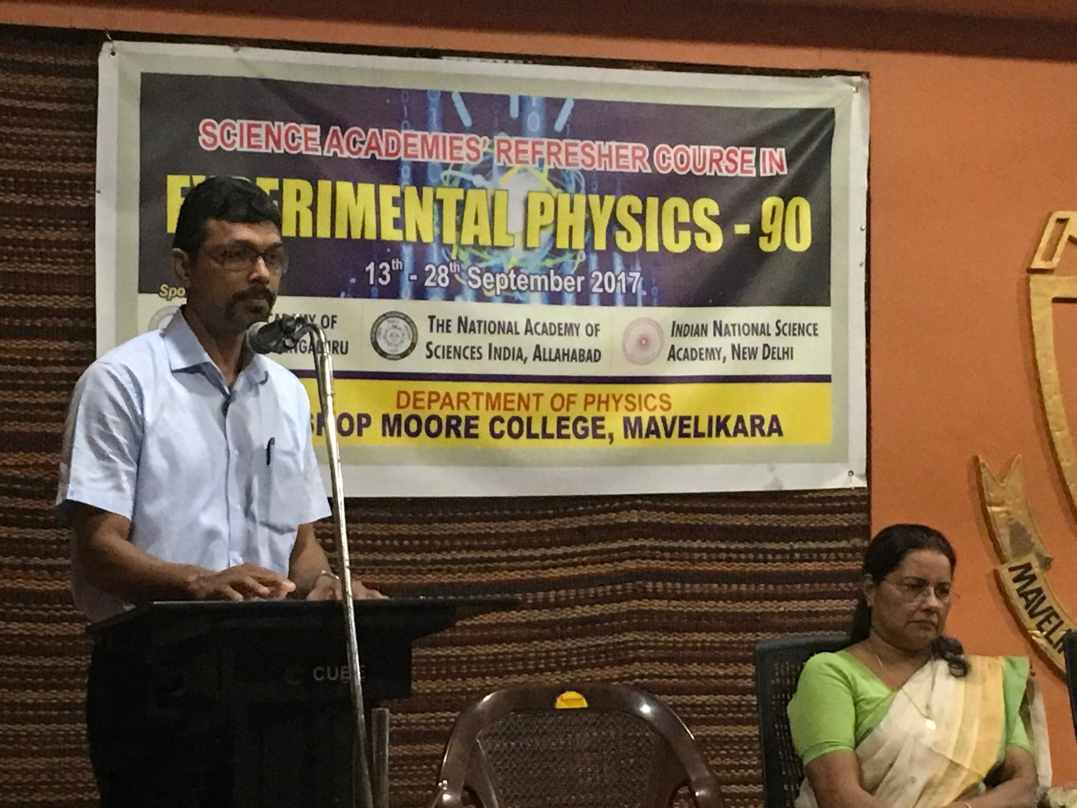
Inaugural fn. felicitation: Dr. Ranjith Mathew Abraham
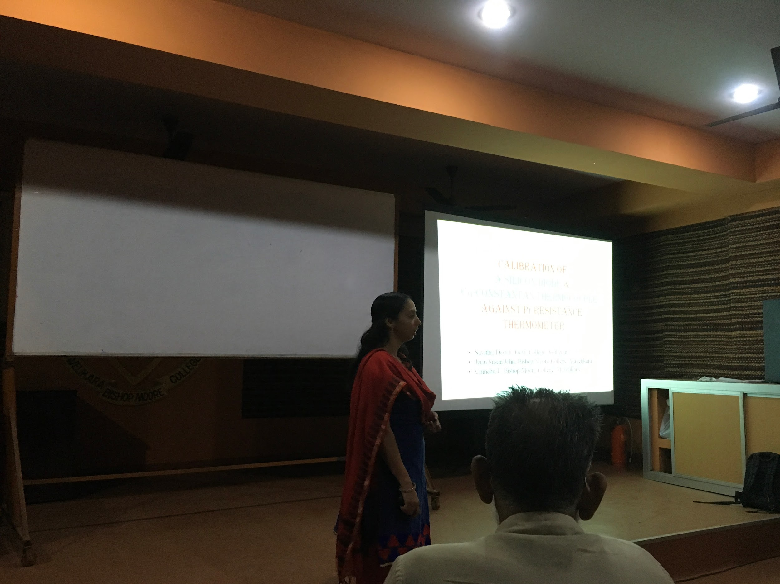
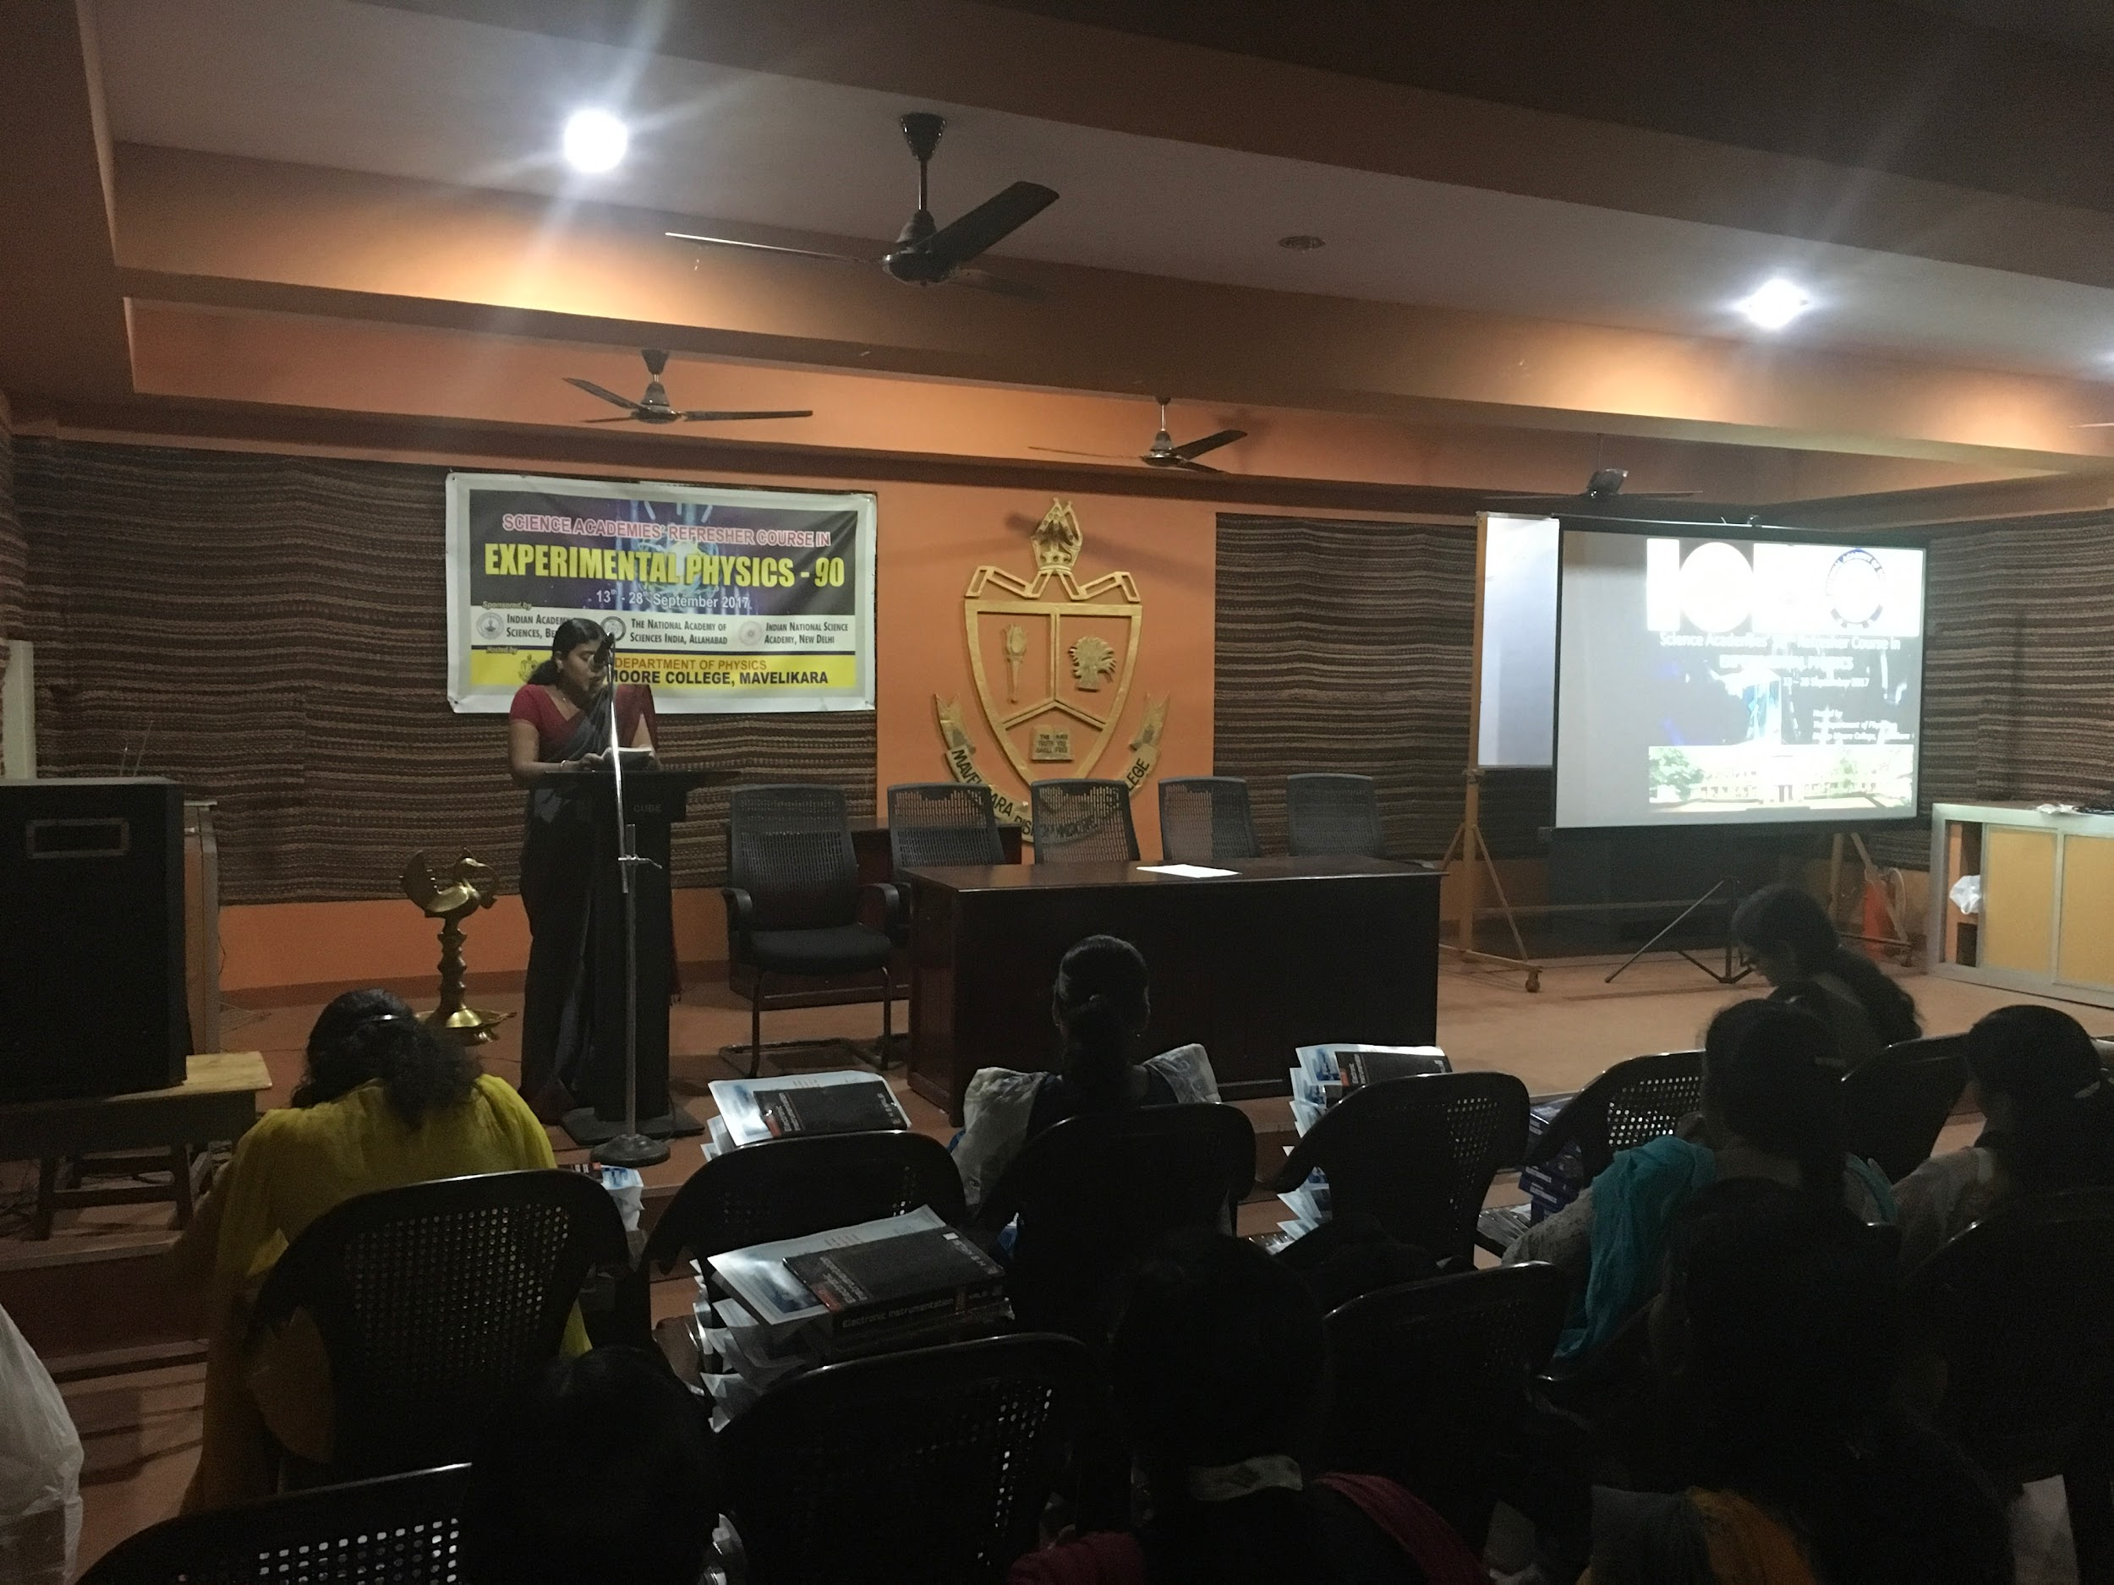
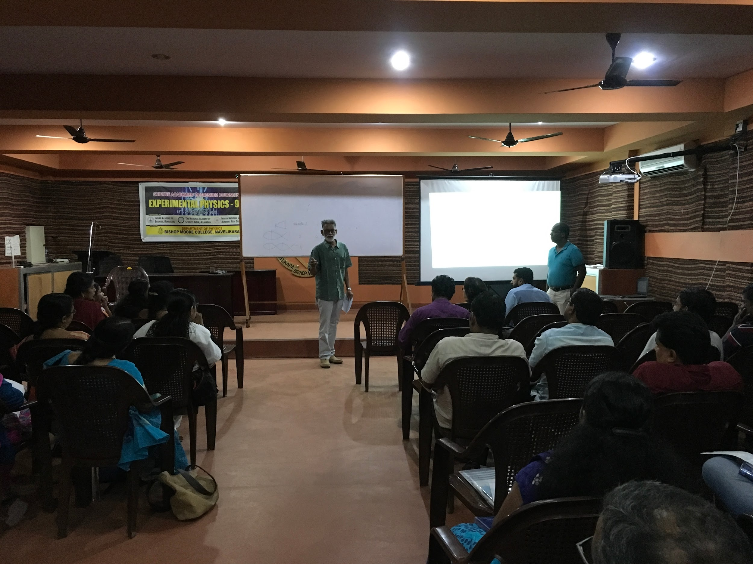
Dr. c S Sundar
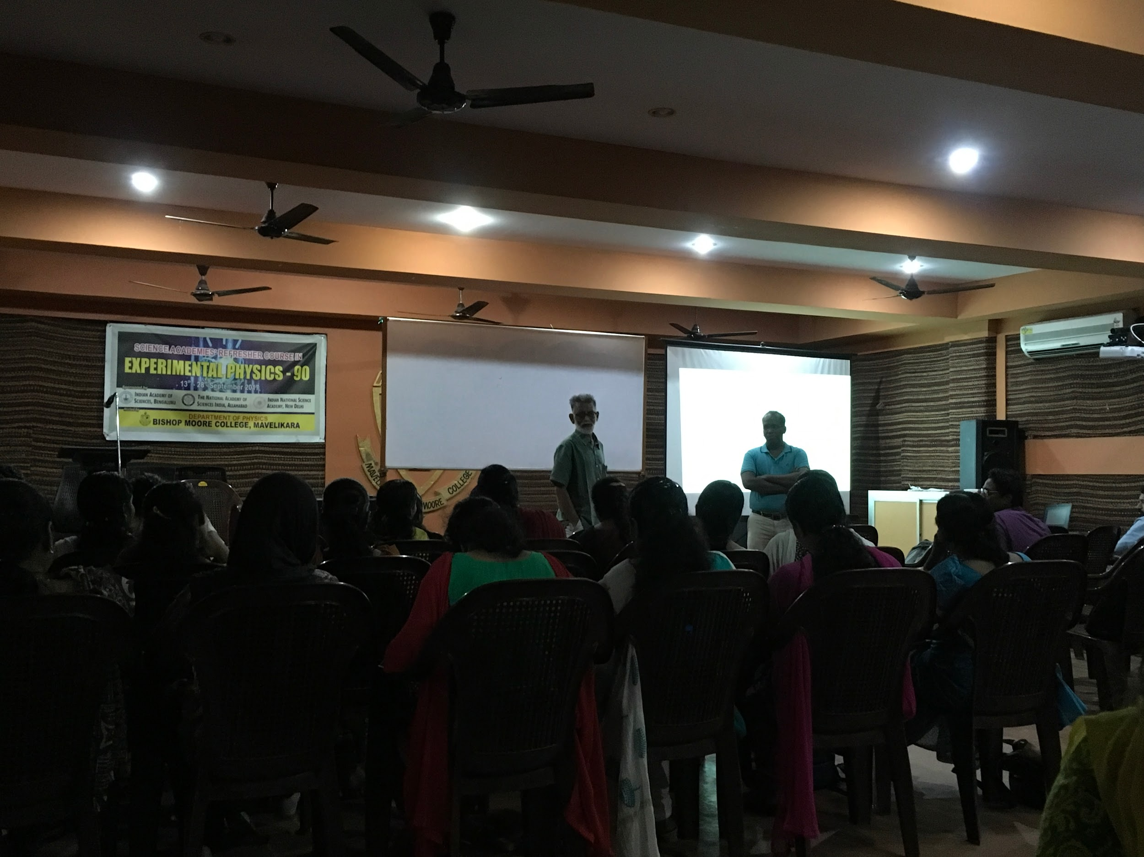
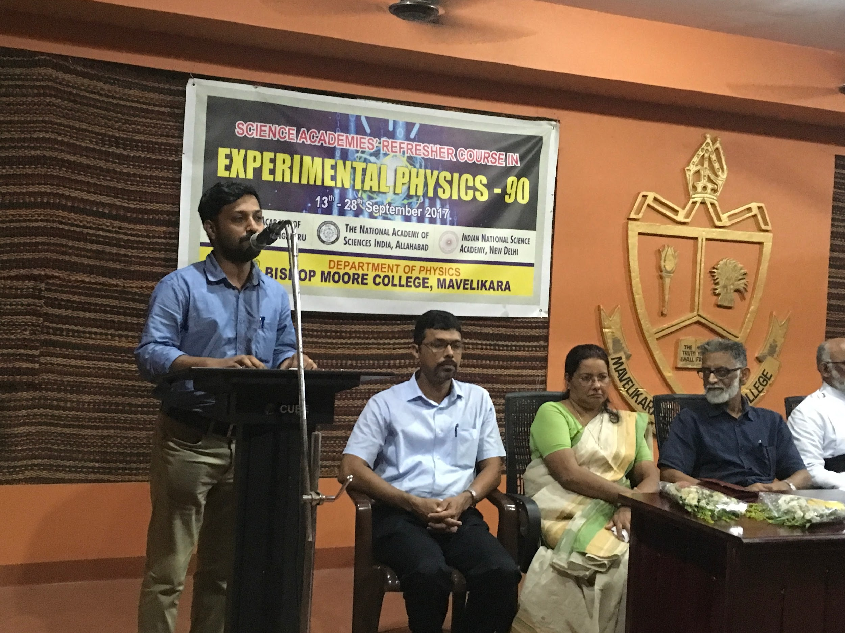
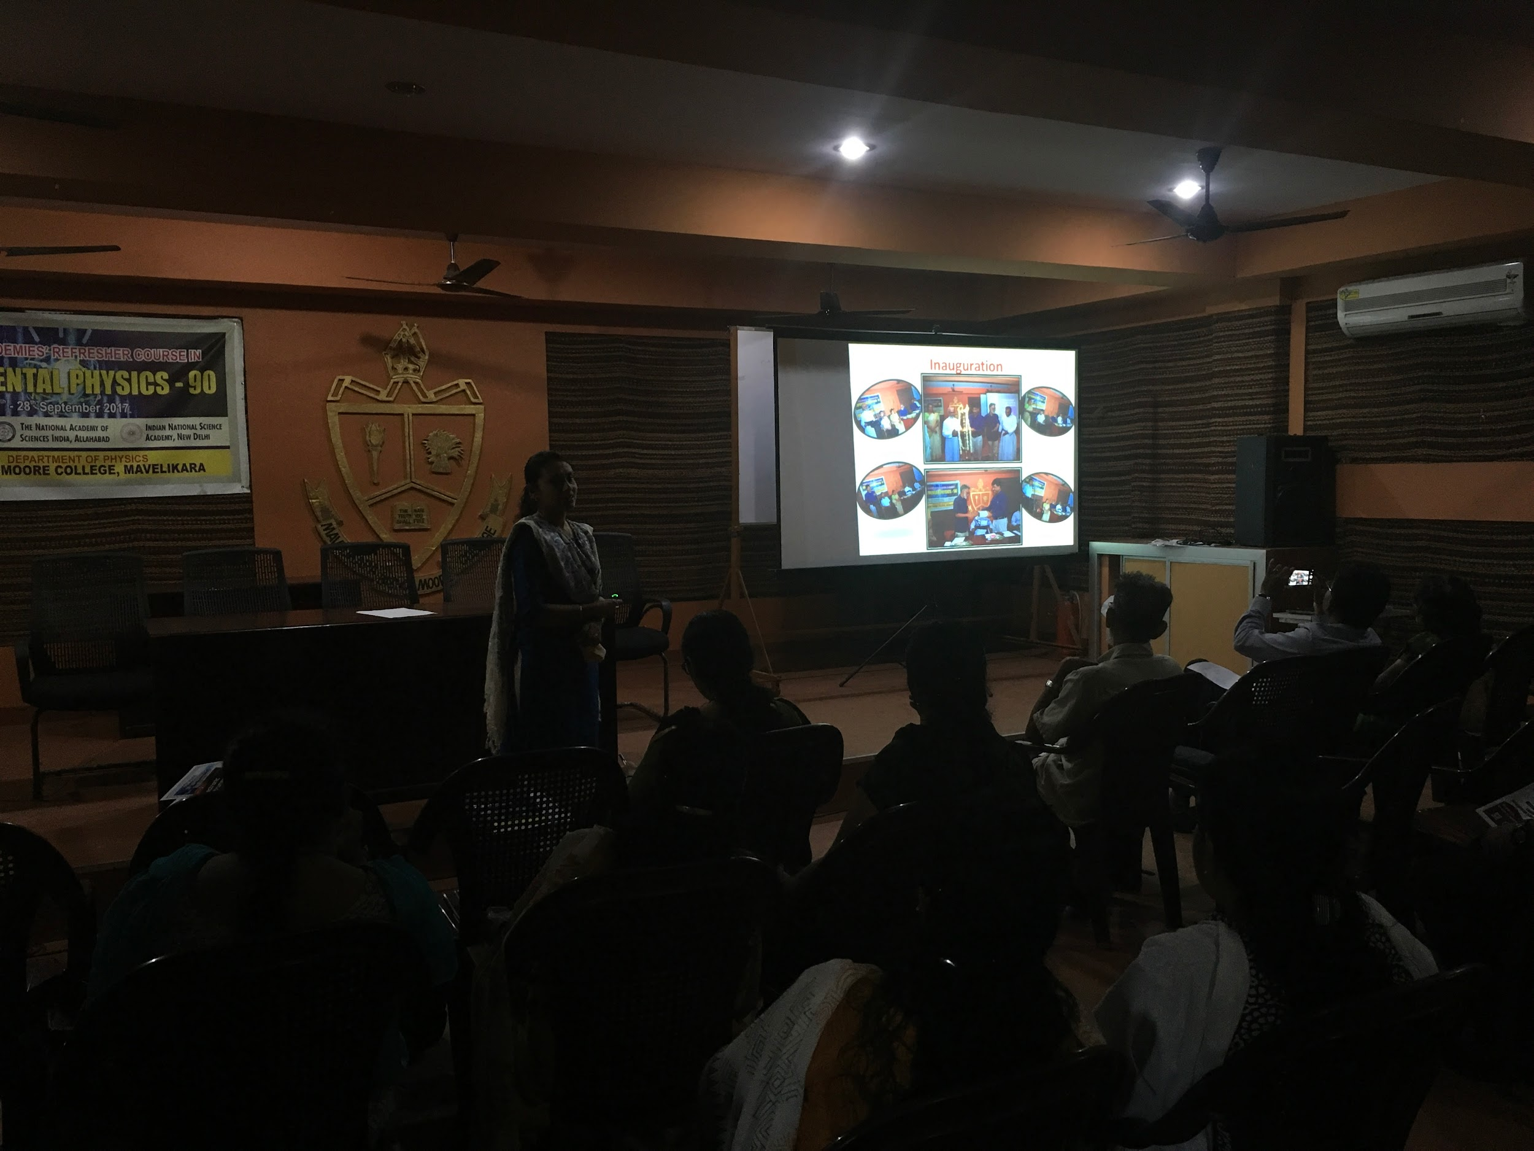
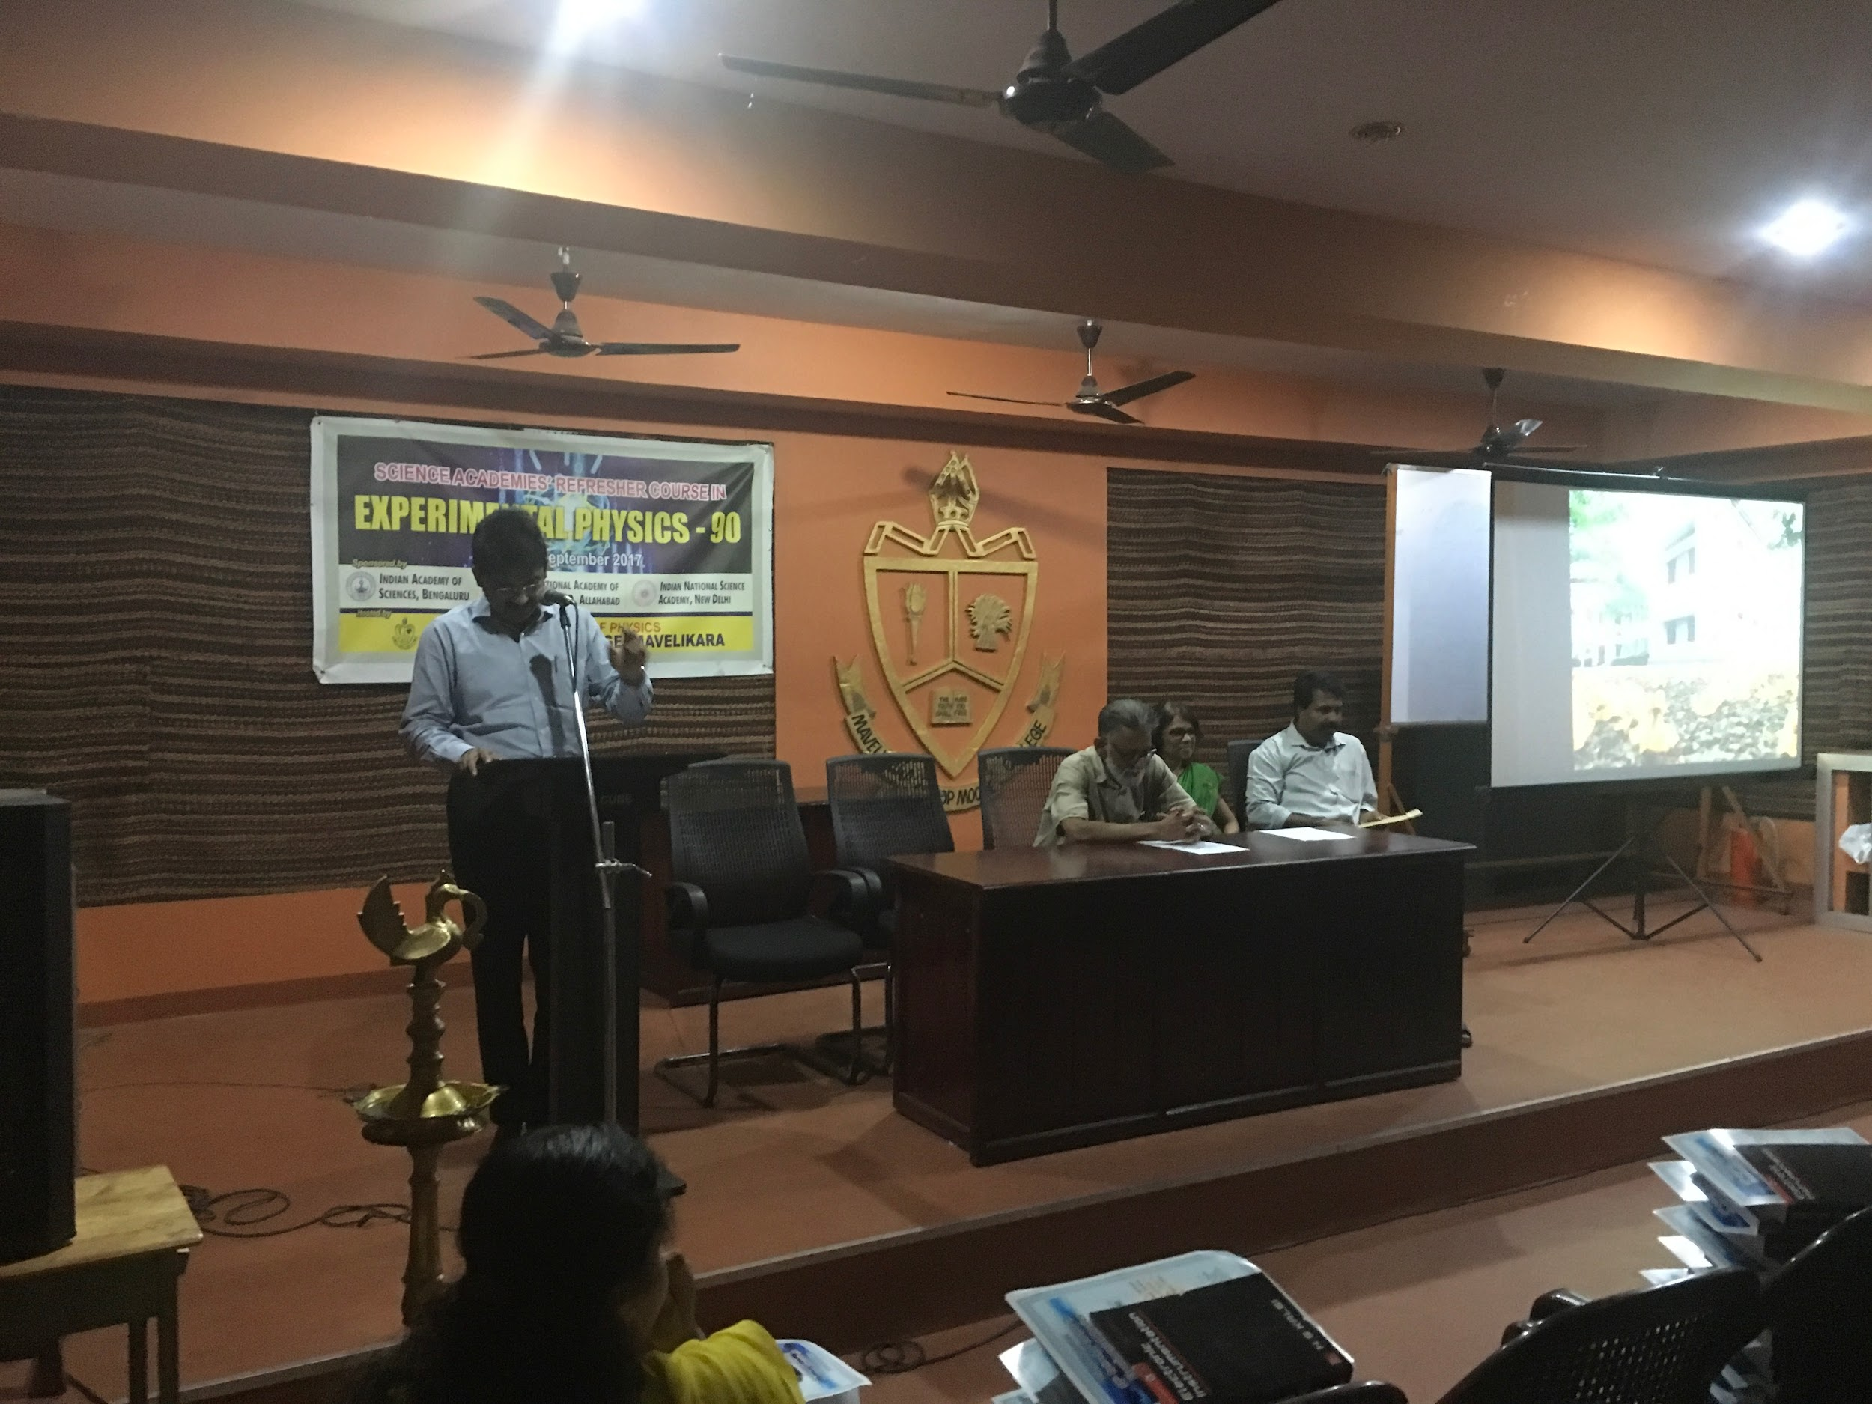
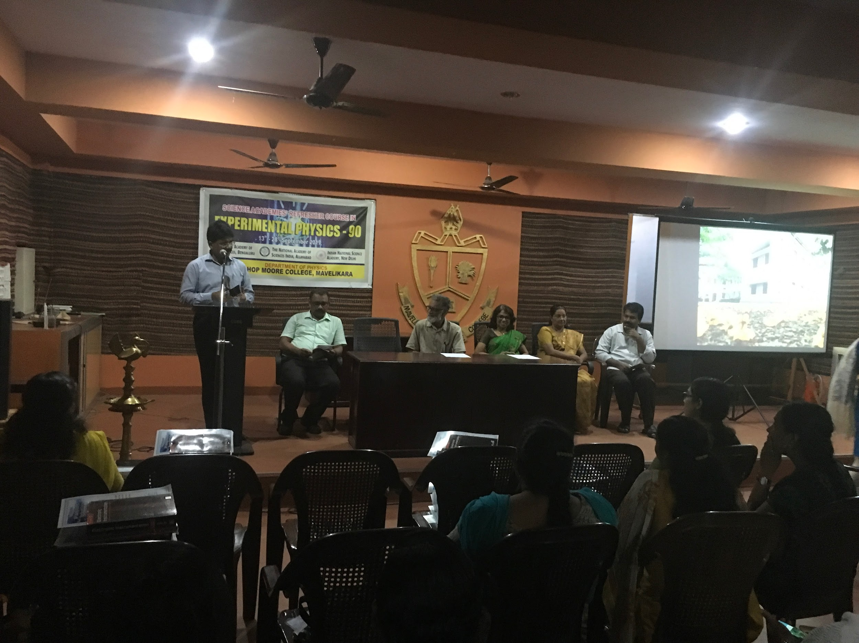
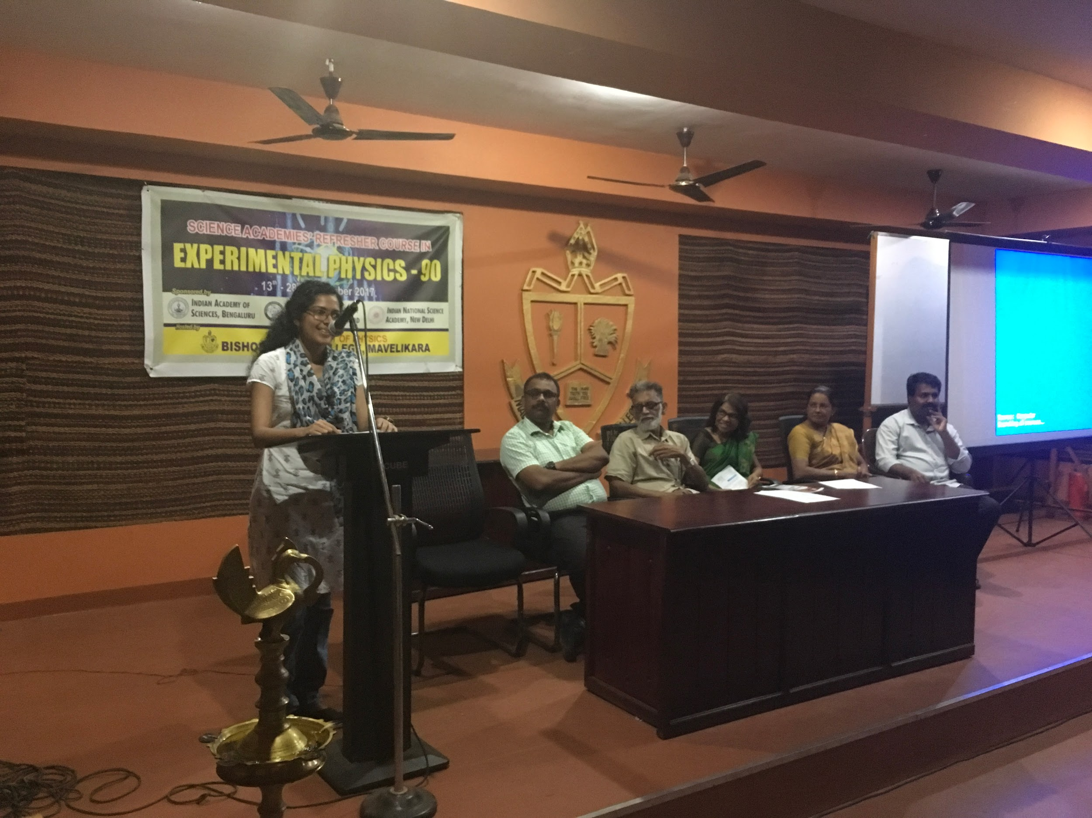

Postal Address
Dr. Jacob Chandy
Principal, Bishop Moore College
Mavelikara. Pin: 690110
Kerala.
Mail Id: bpmoorecollege@gmail.com

Contact Details
Principal : 04792303230
Office :04792303260
Mail Id: bpmoorecollege@gmail.com

Locate Us
Copyrights © 2016, Bishopmoore College. All Right Reserved.
Website Designed,

