Orientation programme for Degree First sem: 21 Aug 2017

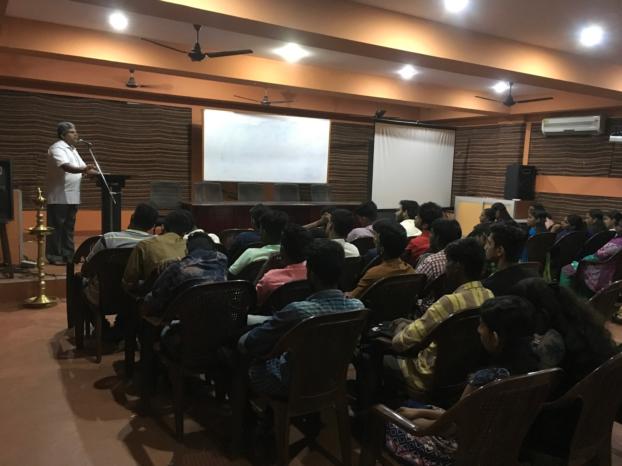

Dr. Harichandran Achari, Former Associate Professor of Malayalam, leading orientation class for Semester 1 students

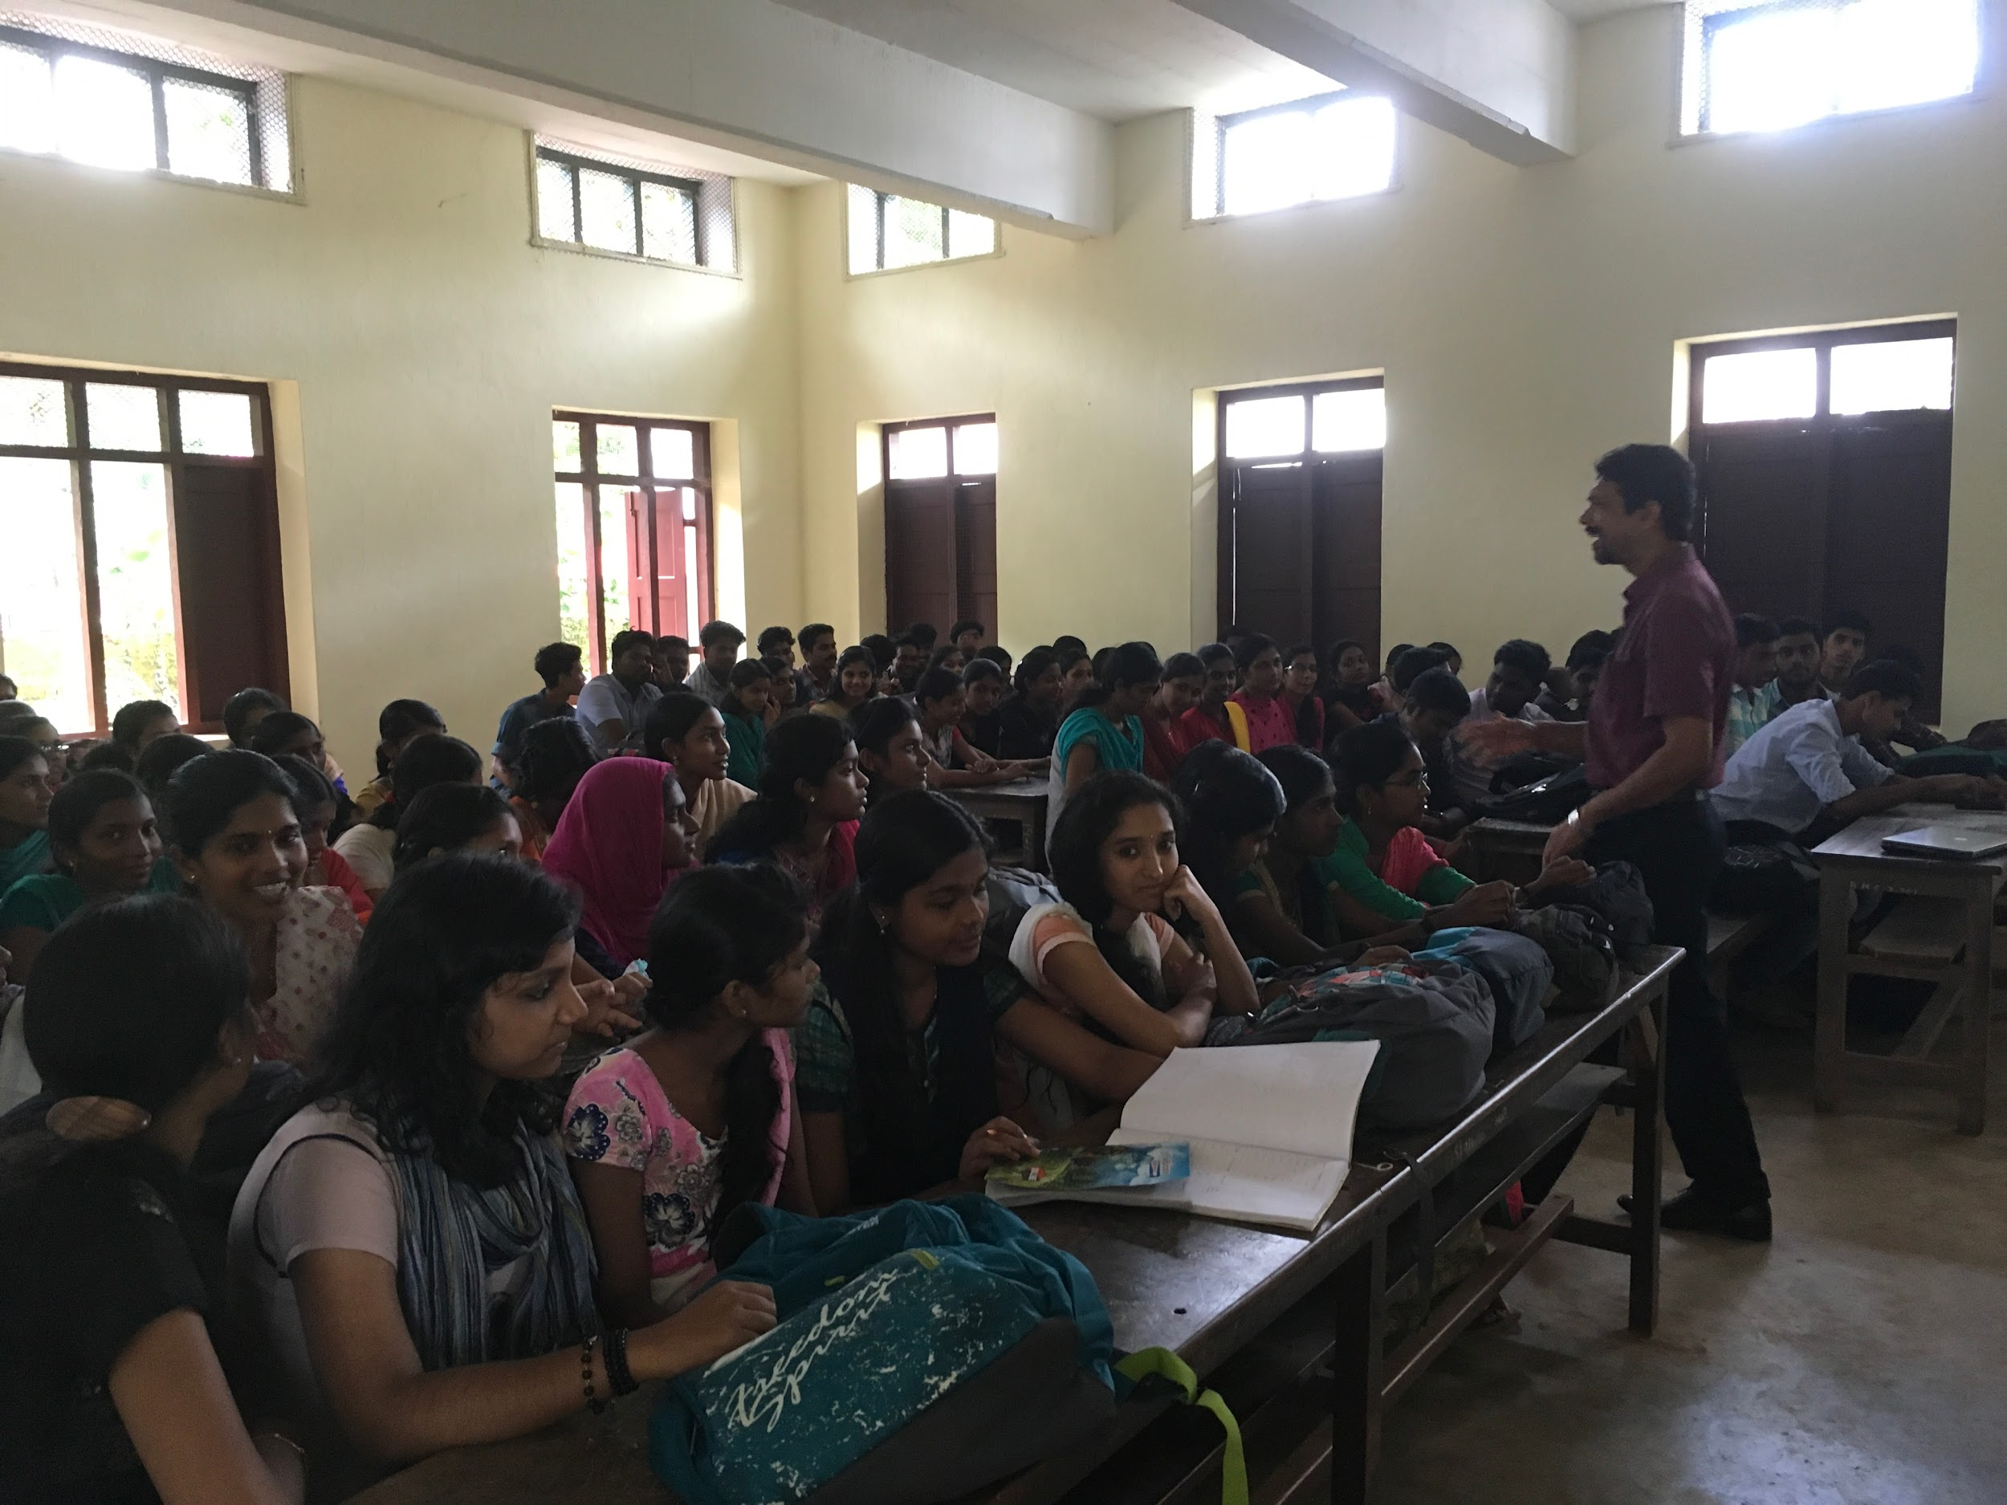

Dr. Ranjith Mathew Abraham, Associate Professor of Economics & IQAC Co-ordinator leading classes for semester 1 (Physics, Chemistry, Mathematics) students

