National Sports Day Celebrations: 29 Aug 2017

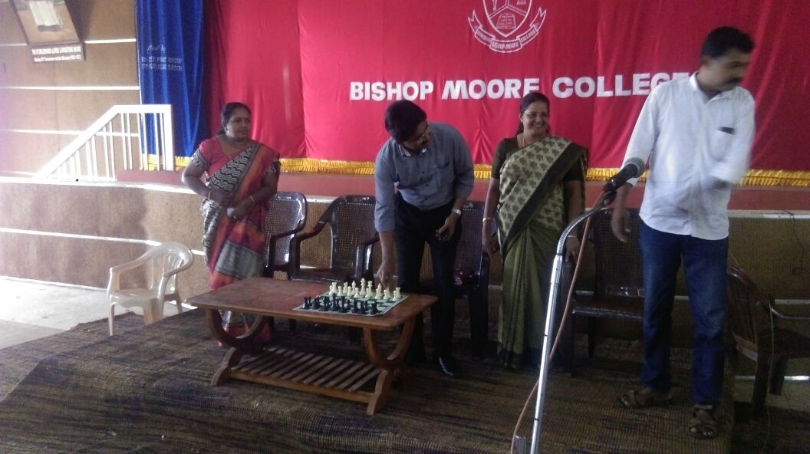

Dr. Jacob Chandy inaugurates Chess Club

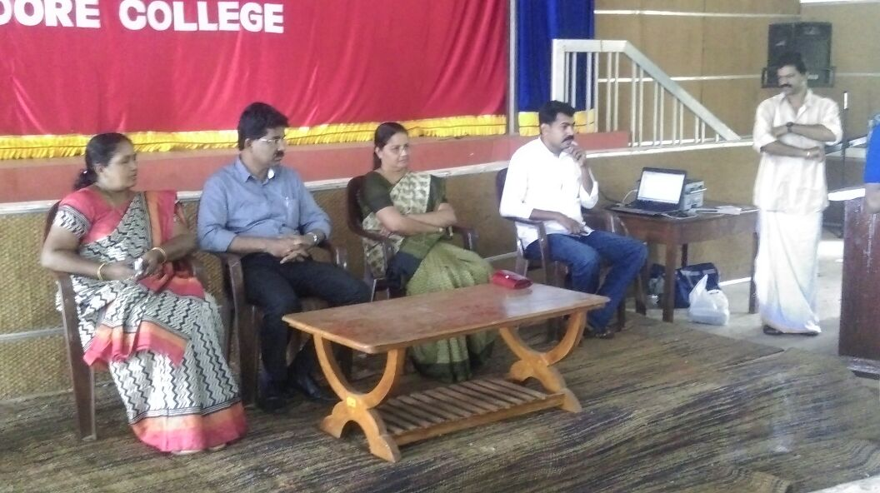

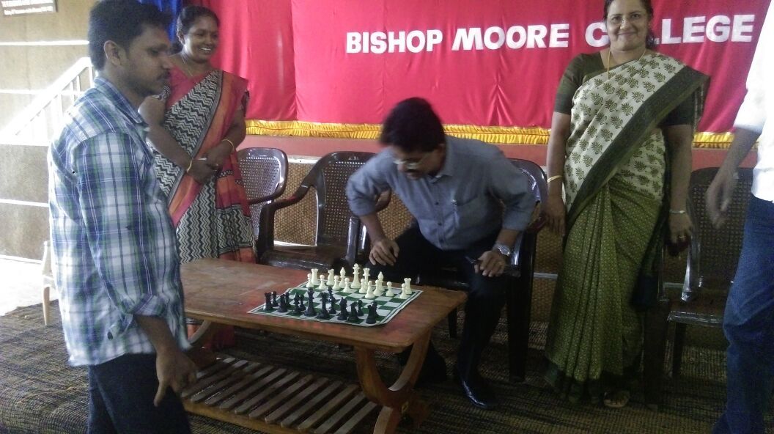

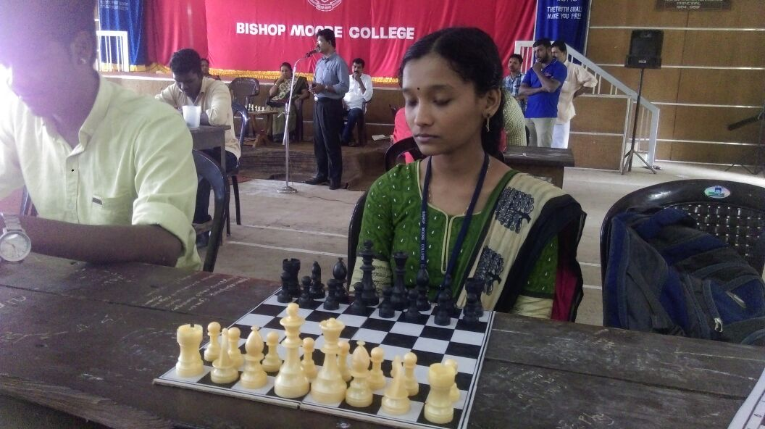

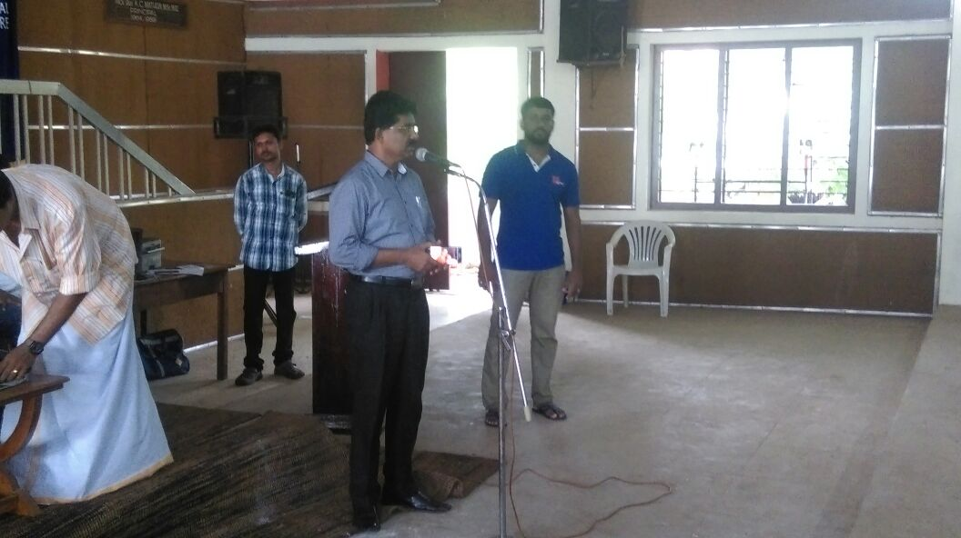

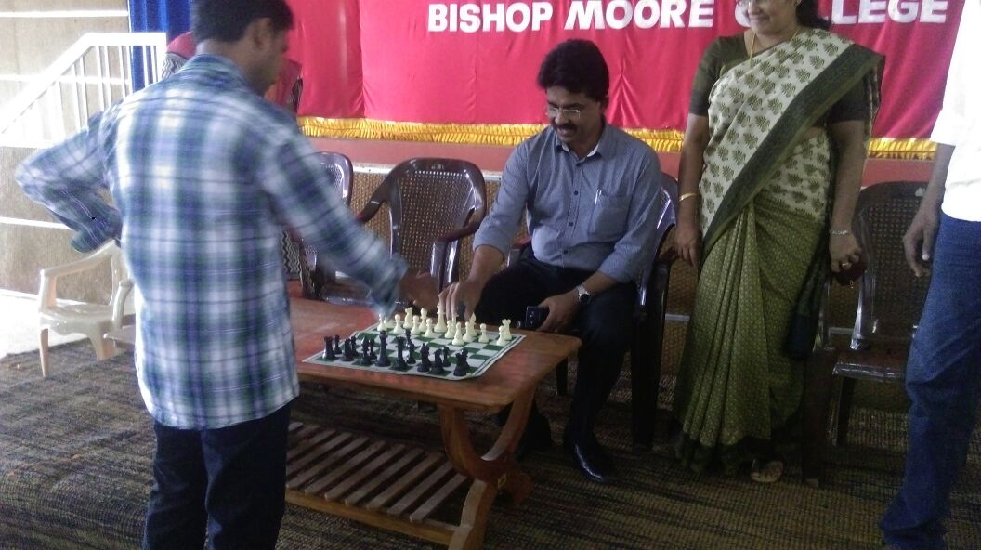

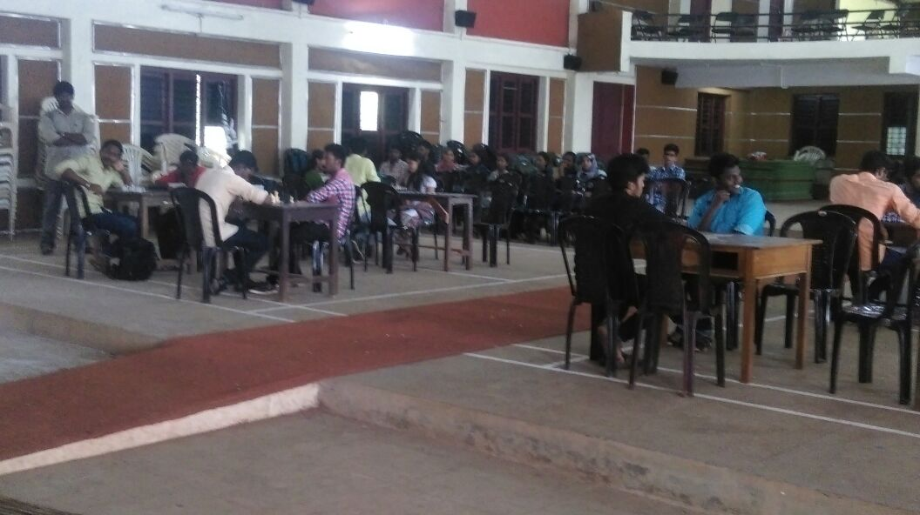

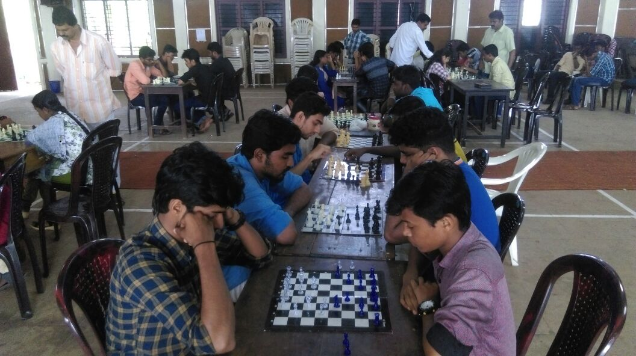

Inter Department Chess Competition

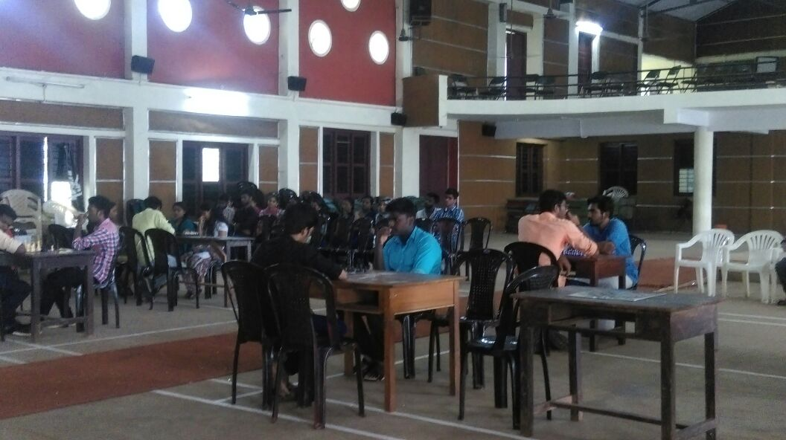

### Postal Address

Dr. Jacob Chandy

Principal, Bishop Moore College

Mavelikara. Pin: 690110

Kerala.

Mail Id: bpmoorecollege@gmail.com

### Contact Details

Principal : 04792303230

Office :04792303260

Mail Id: bpmoorecollege@gmail.com

### Locate Us

Copyrights © 2016, Bishopmoore College. All Right Reserved.

Website Desig