Intercollegiate achievement: 10 Nov 2017

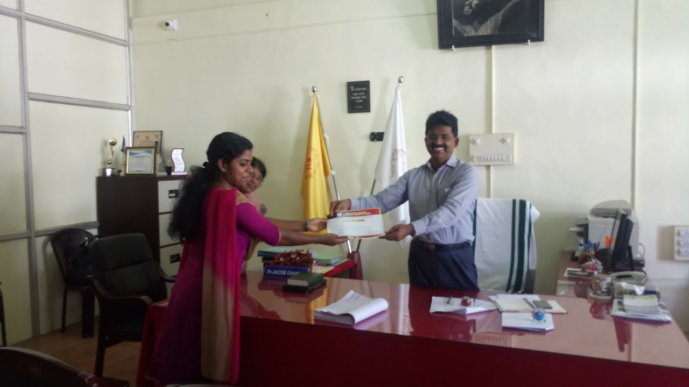

Reshma Rajan of MA English being congratulated for securing third prize in Seminar competition held at Christian College, Chengannur