CSIR NET achievements: 30 Nov 2017



Akhil Thomas Panicker of 2013-16 BSc Physics batch cleared NET with All India Rank 69

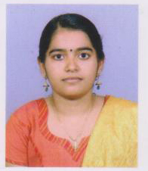

Athira R K Nair of Msc Botany 2014-16 batch (University first rank) cleared CSIR JRF with All India Rank 57.

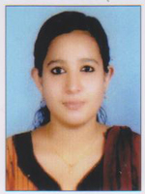

Nigina of Msc Botany 2014-16 batch cleared CSIR JRF with All India Rank 67.

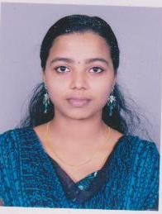

Sneha Mohan of zoology 2011-14 batch cleared CSIR JRF

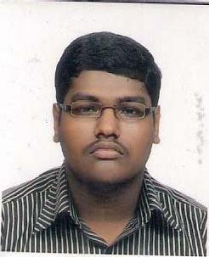

Nisanth H.P. of BSc Zoology 2010-13 batch once again cleared NET