Arduino Robotics Workshop: 12 June 2017

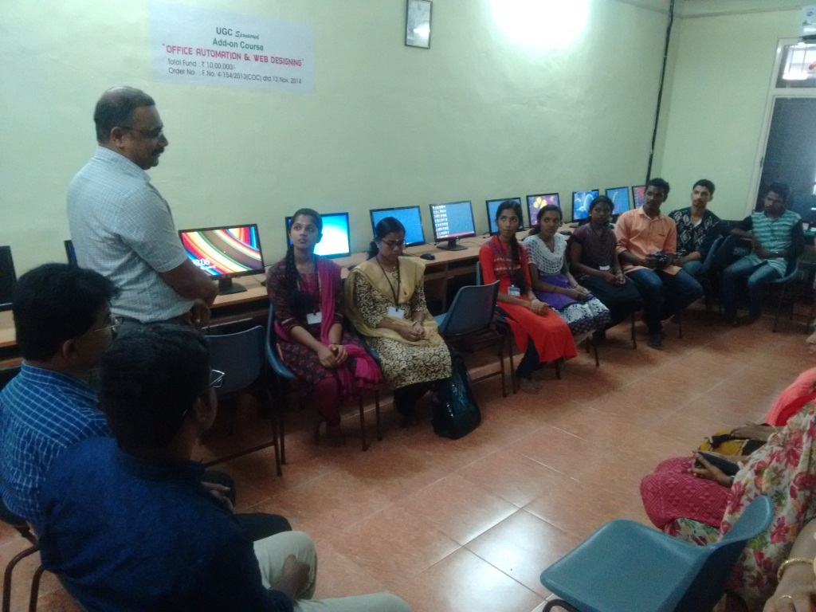

Welcome speech by Dr. D. Sajan (HOD)

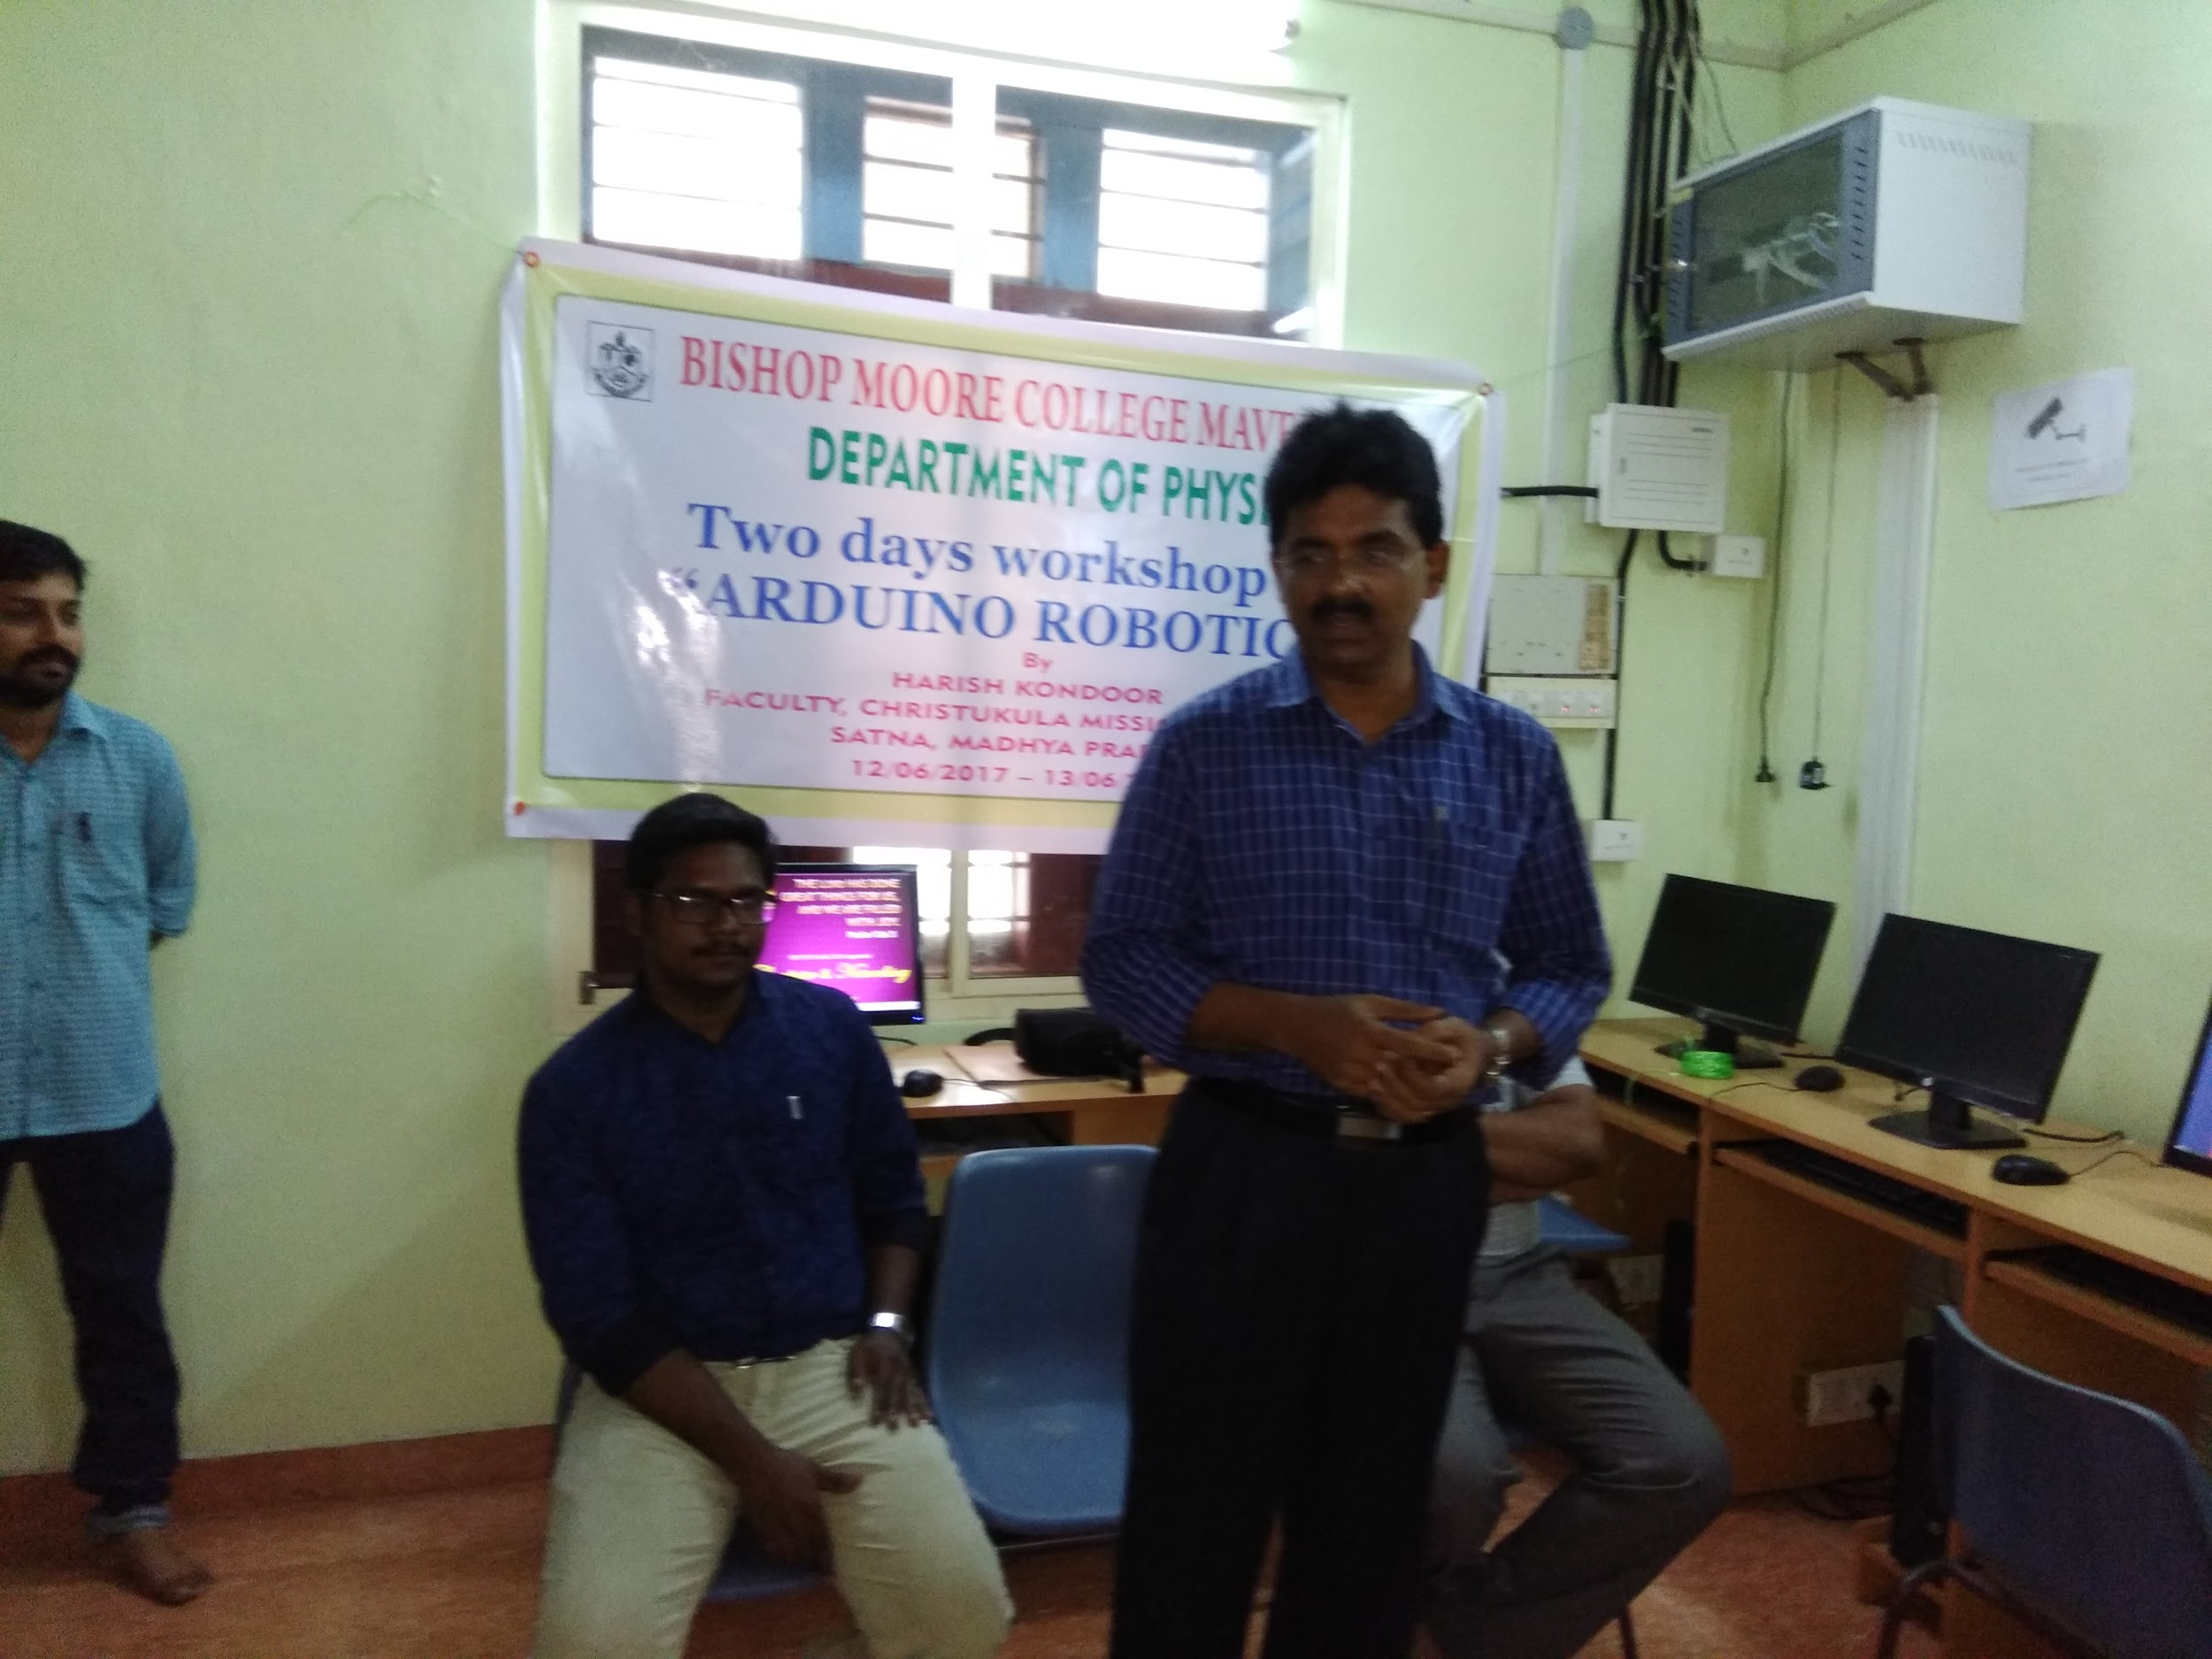

Dr. Jacob Chandy (College Principal) inaugurates the workshop

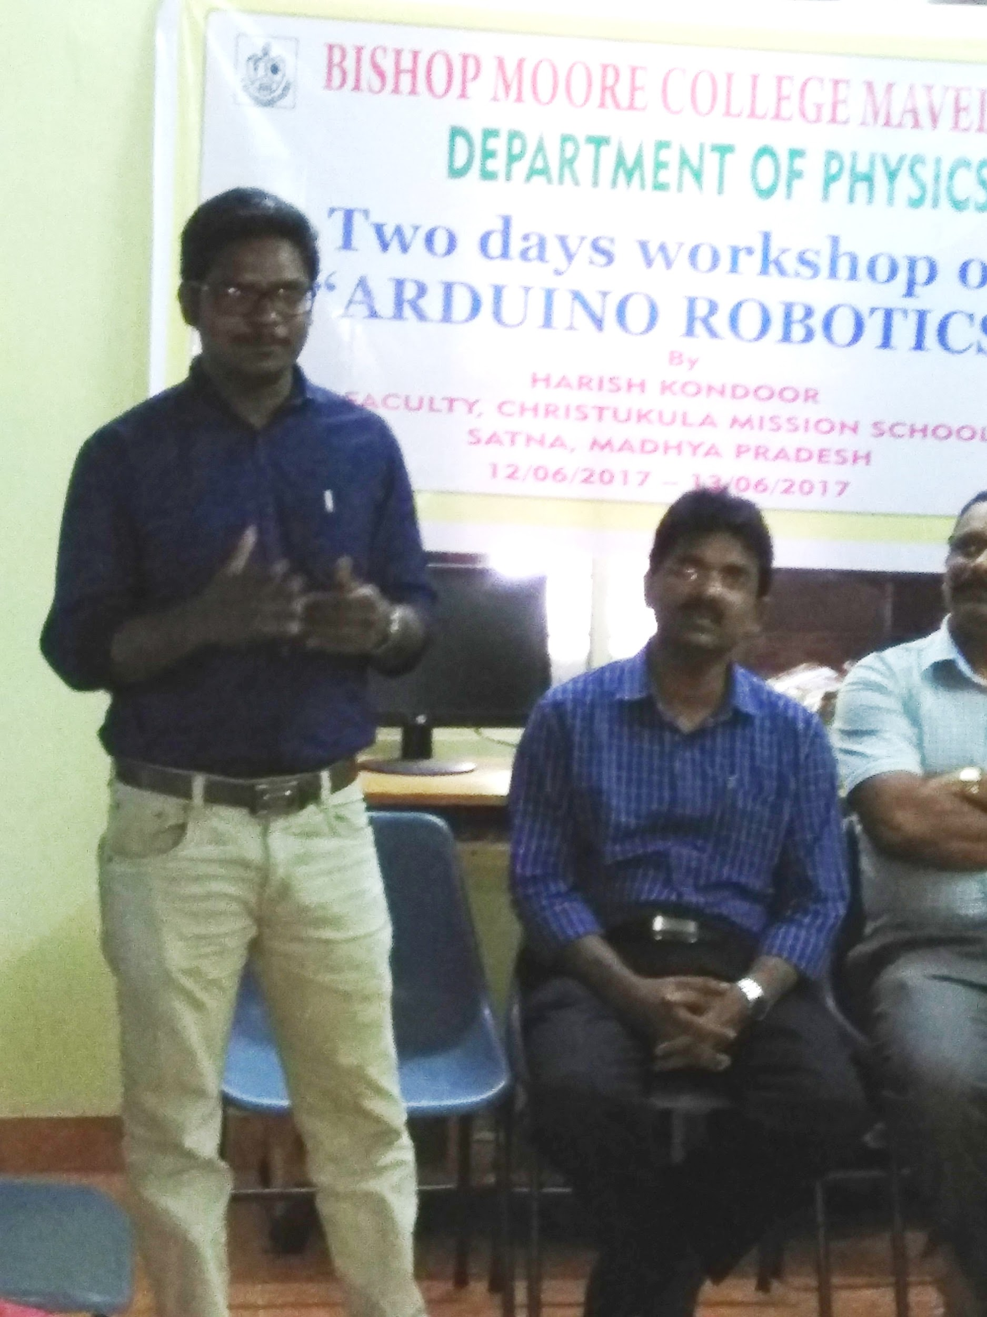

Mr. Harish Kondoor (Resource Person)