Reunion of 1970-73 batch: 17 June 2017

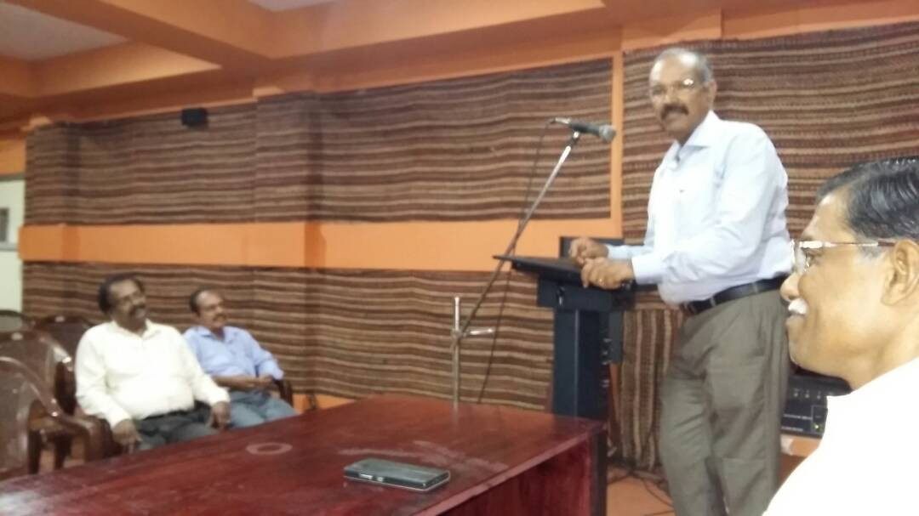

### Postal Address

Dr. Jacob Chandy