[Arun V (S2 BA English) and Vijith Vijayan (BSc S6 Chemistry)participates in All India Inter University Judo Championsh](http://bishopmoorecollege.org/gallery/?album=4826)Participation in All India Inter University Judo Championship

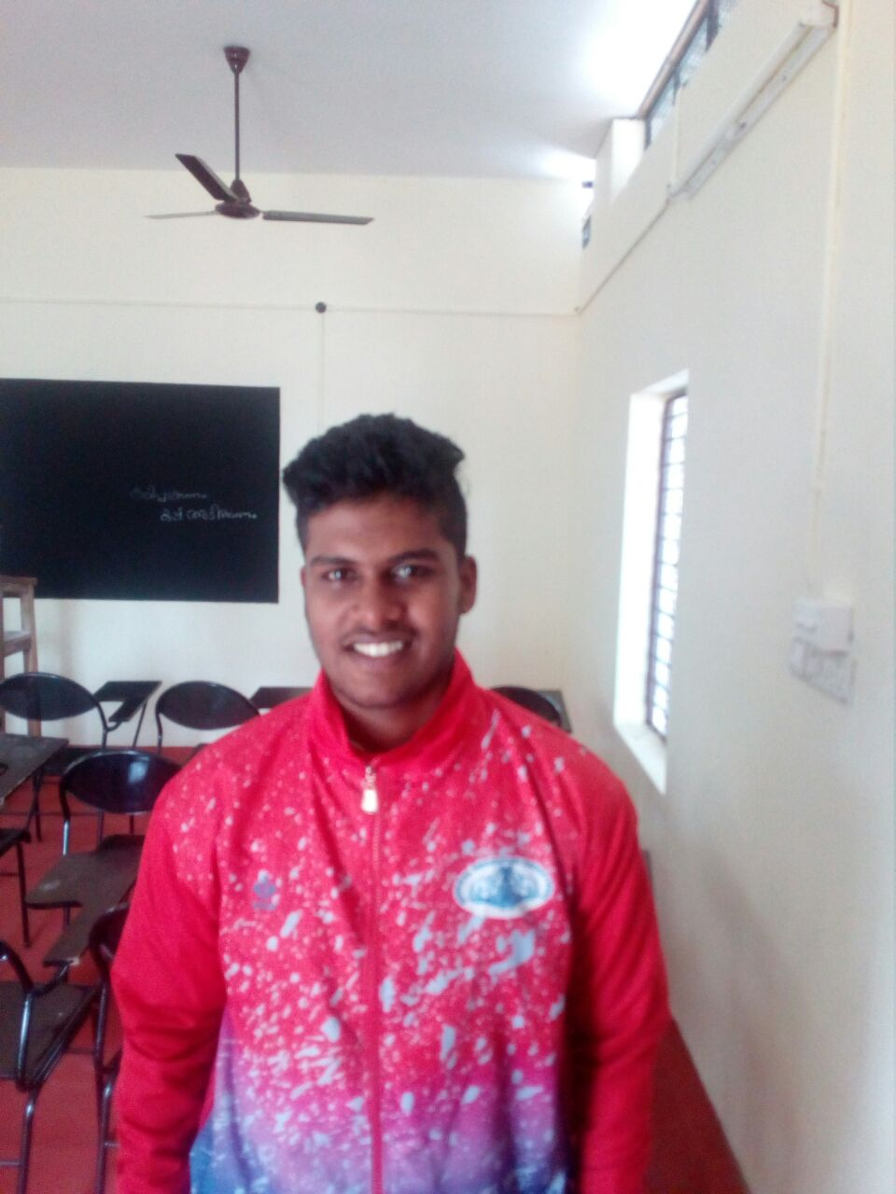

Arun V (S2 BA English)

