* [National Books and DC Books jointly organized Book Fair in the college on 13 October 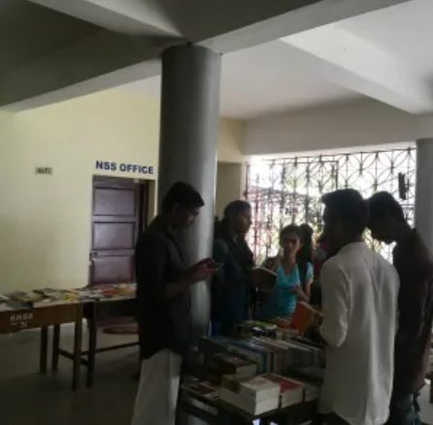2017 View photos](http://bishopmoorecollege.org/gallery/?album=4294)