NCC cadets at NIC Dhanbad: 4-15 Sep 2017

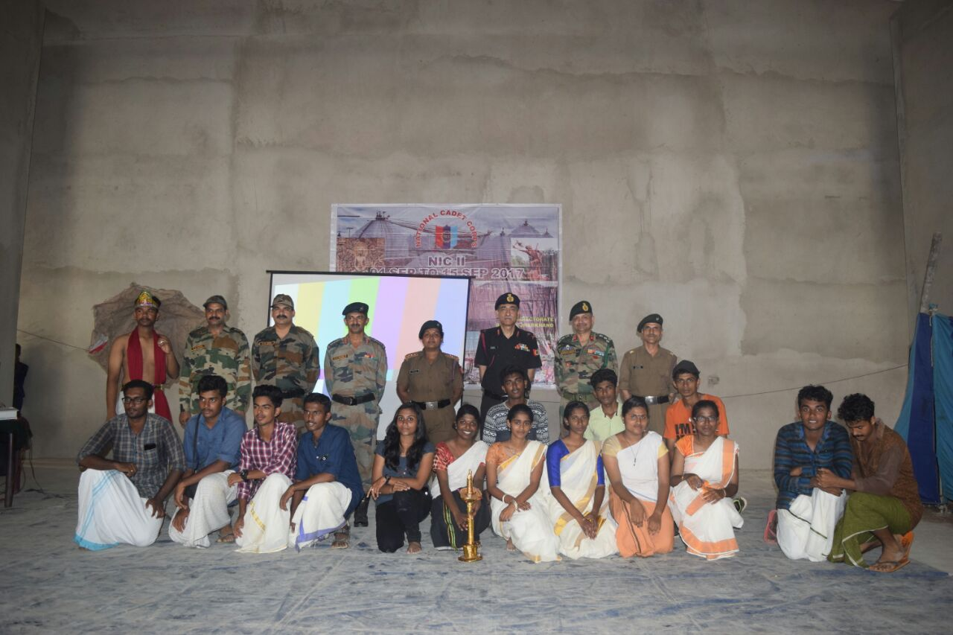

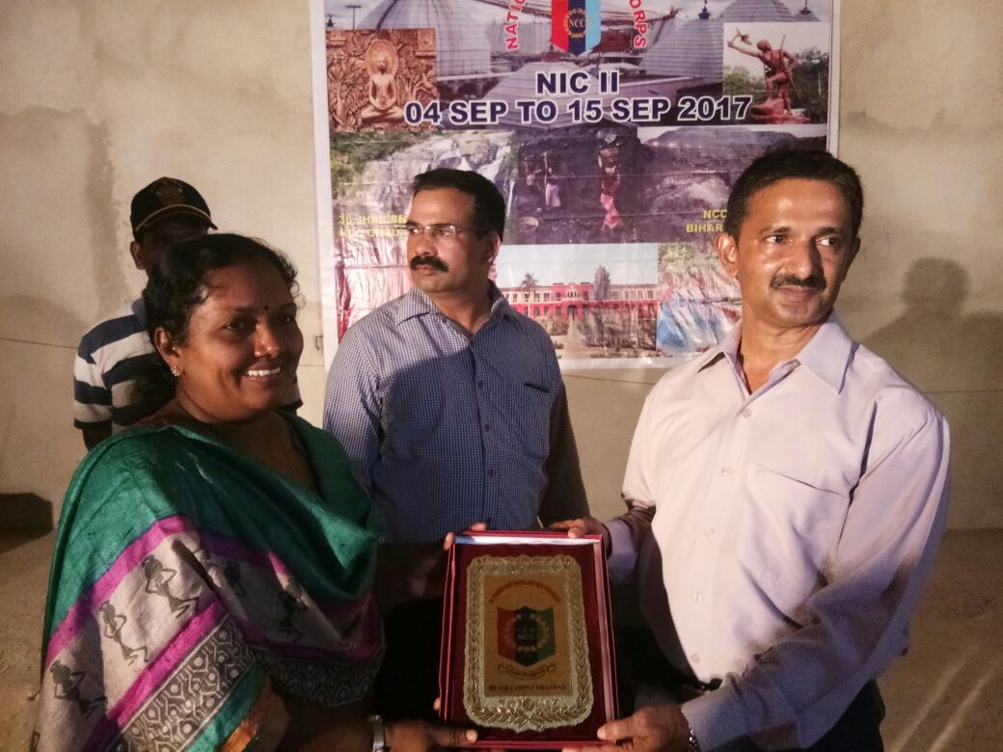

Kerala wins first prize in National Integration Awareness Presentation. Captain. Ciggy P. George of BMC receives the prize

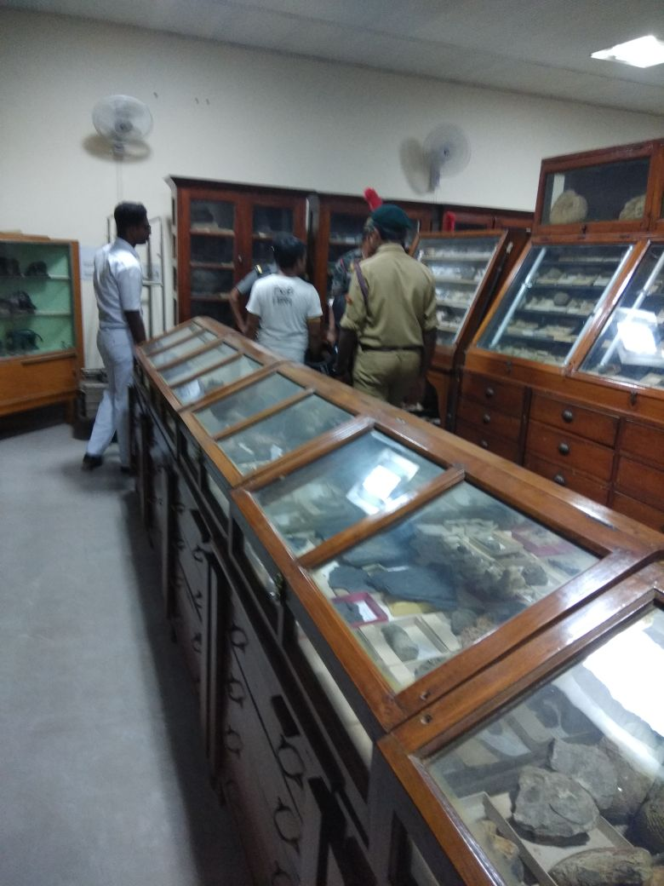

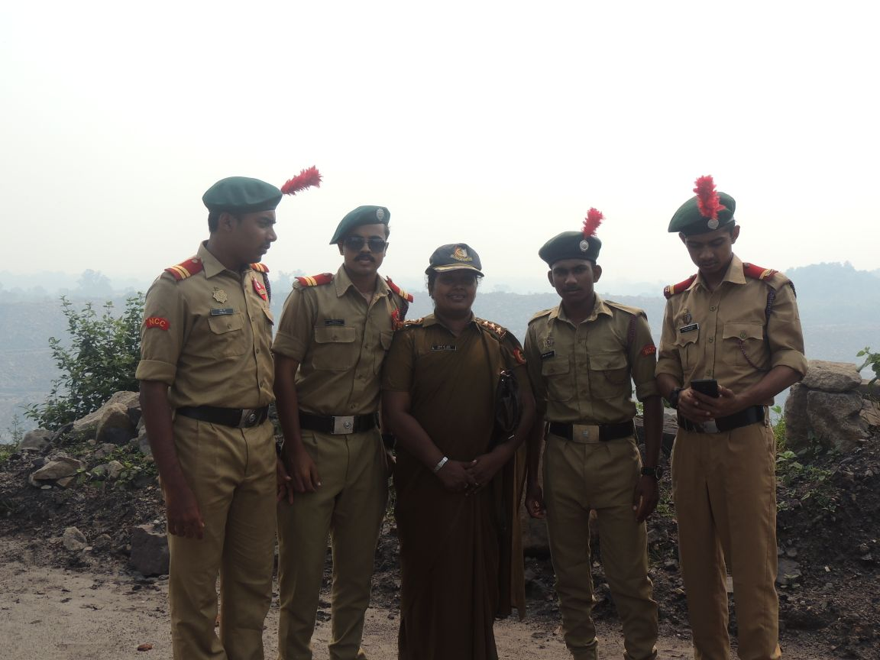

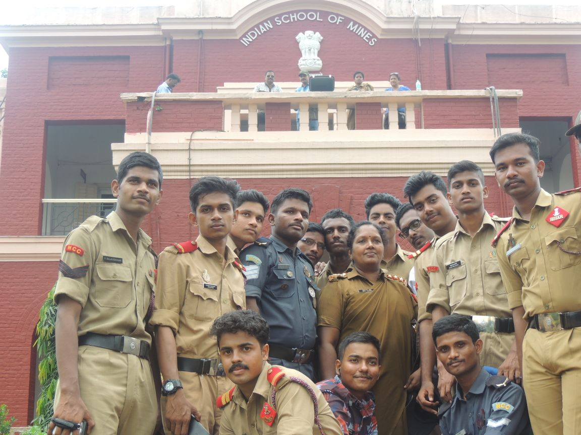

### Postal Address

Dr. Jacob Chandy

Principal, Bishop Moore College