MICSA inaugurated: 17 Nov 2017

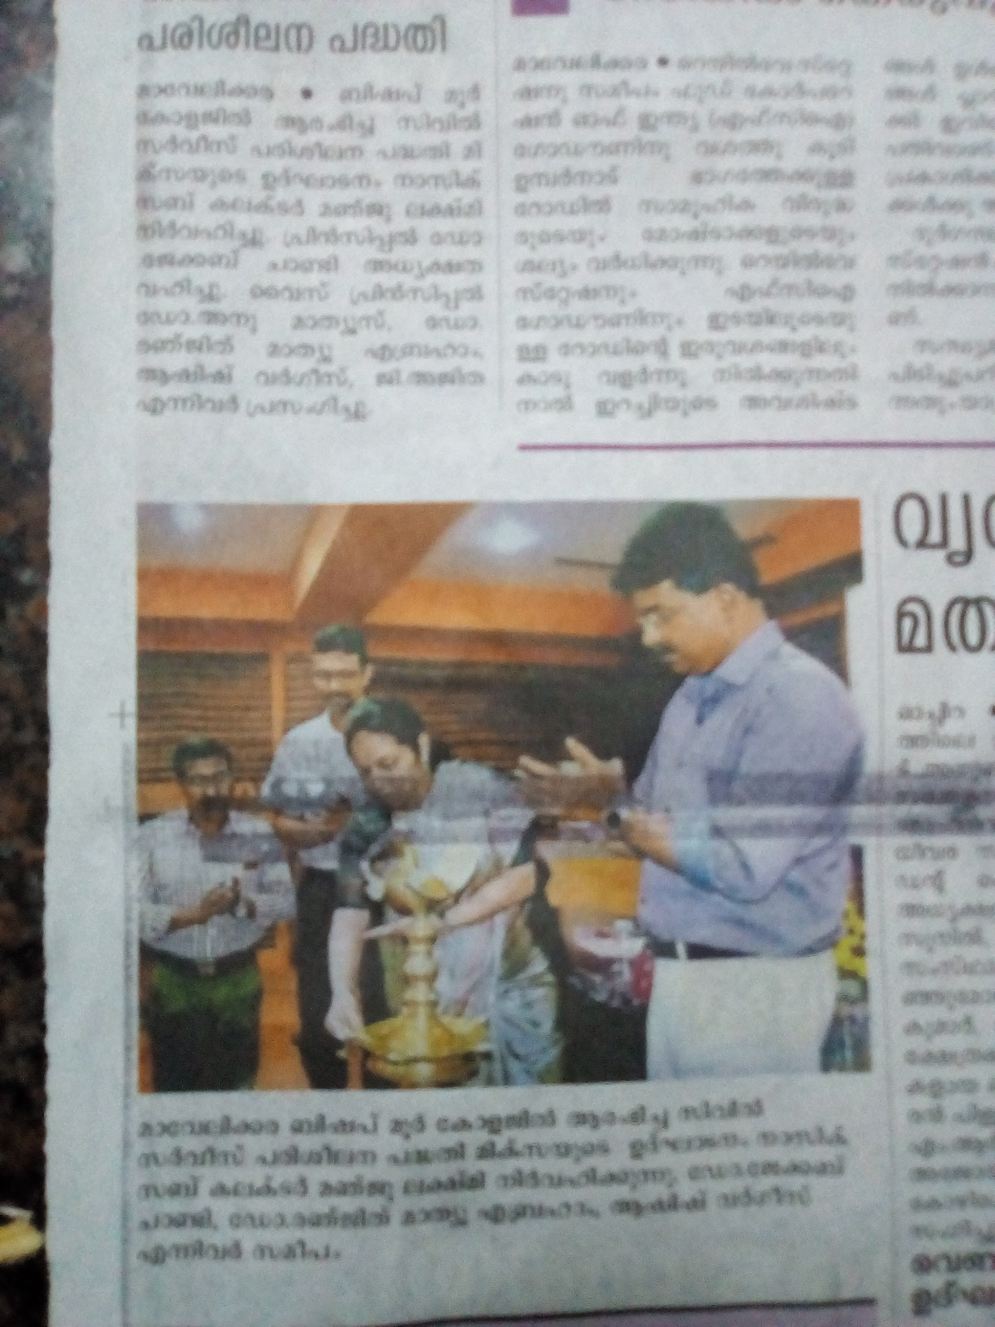

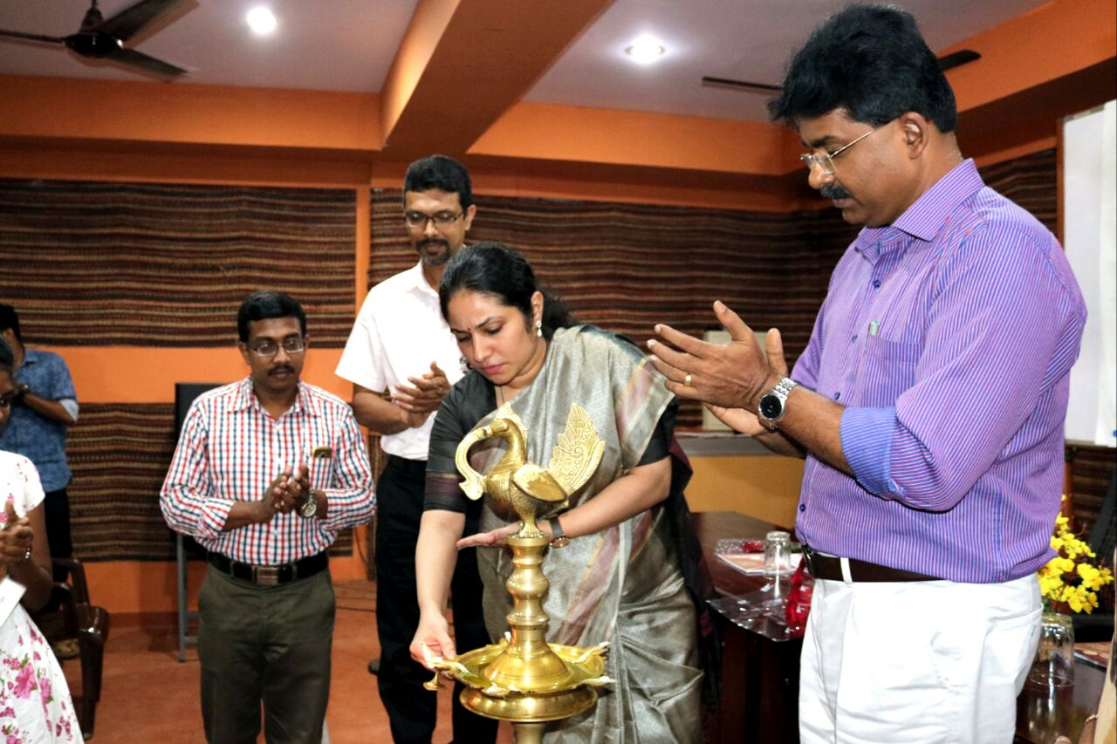

Moore Initiative for Civil Service Aspirants(MICSA) inaugurated by Nasil Sub Collector Smt. Manju Lekshmi

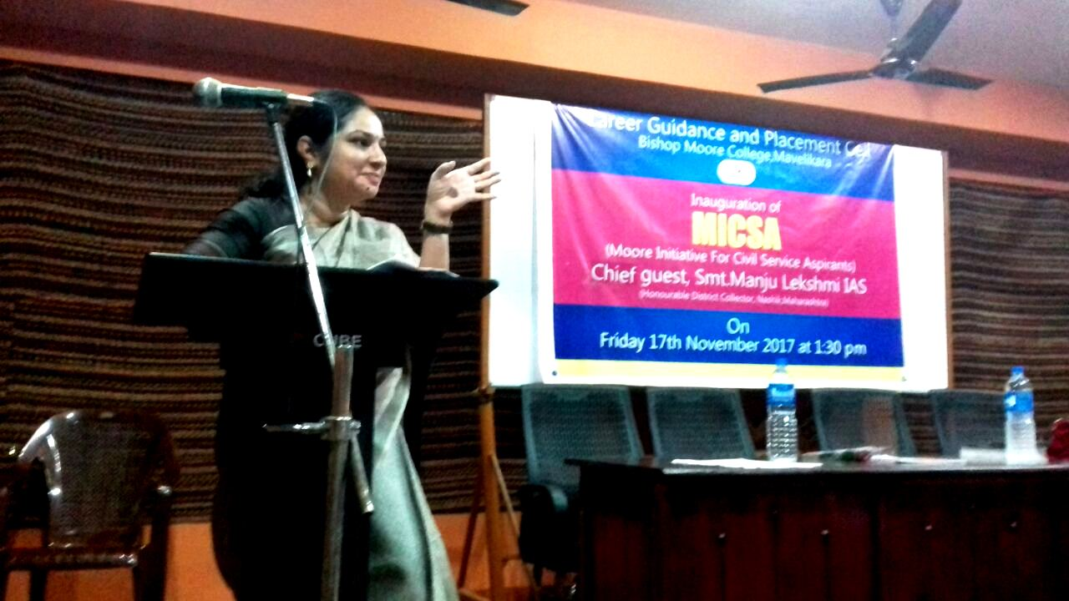

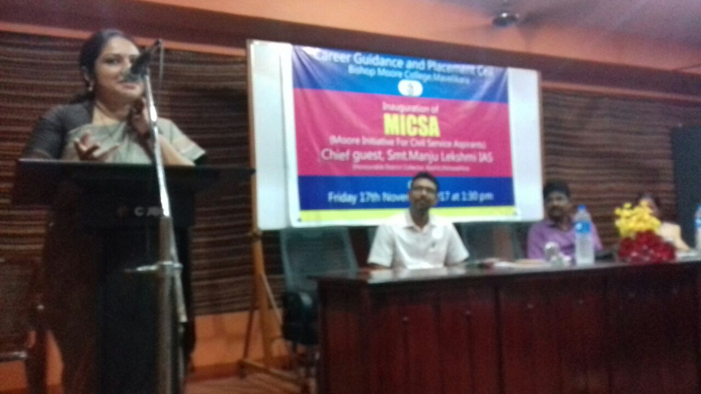

Speaker: Kurias Kumbalakkazhi