Economics Association inauguration: 1 Nov 2017

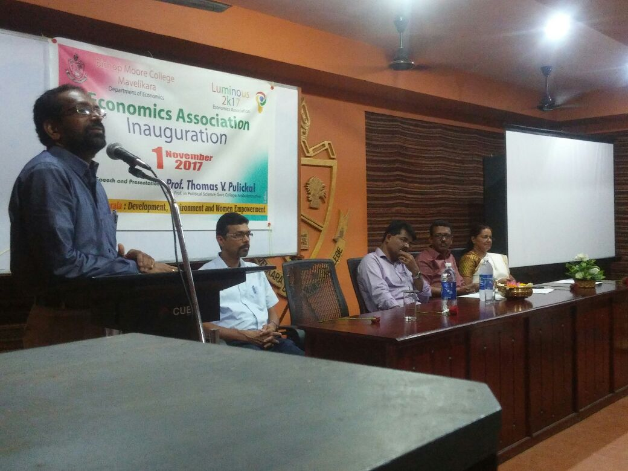

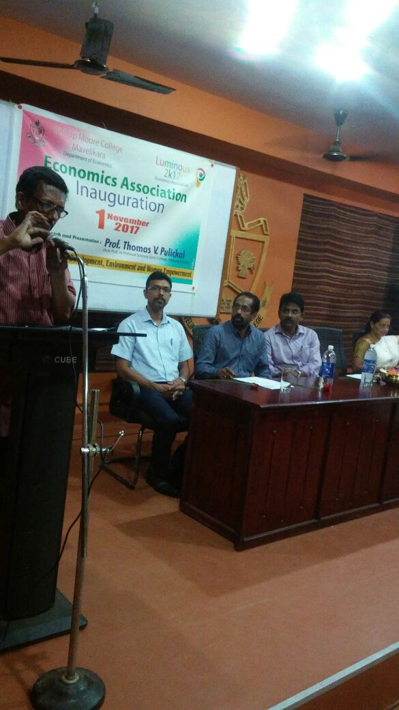

Dr. Thomas V. Pulickal