Debate organised by BPCL, Kochi: 9 Feb 2018

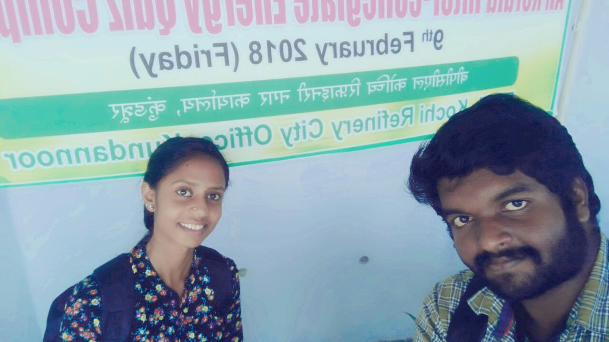

Sreehai Pillai S6 BCom Anusha Unni S1 MSc Botany won the second prize

Sreehai Pillai S6 BCom Anusha Unni S1 MSc Botany won the second prize