Bishop MM John Memorial lecture: 1 March 2018

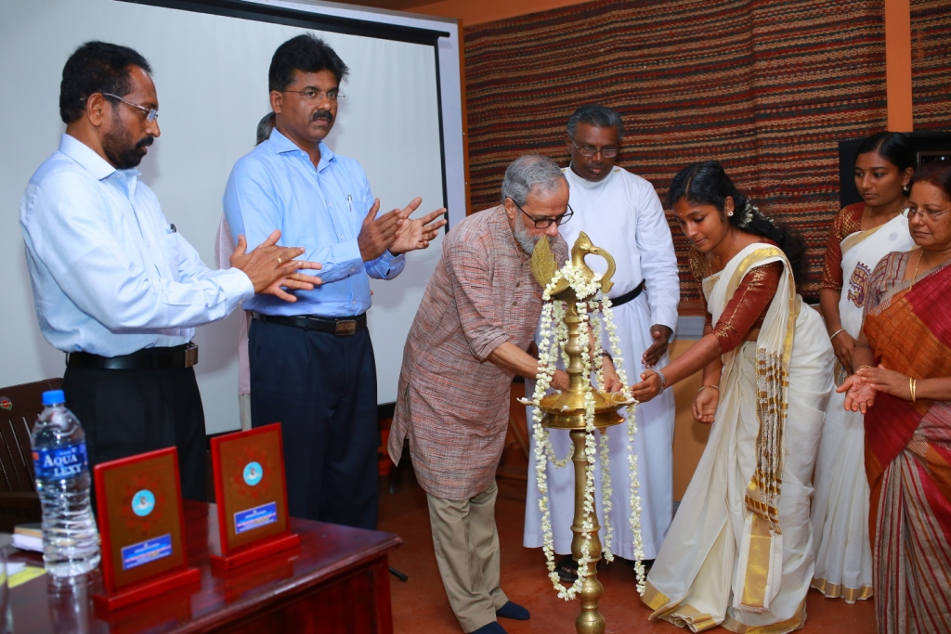

Dr. Rajan Gurukkal inaugurating the lecture