Annual Alumni Get together: 9 Sep 2017

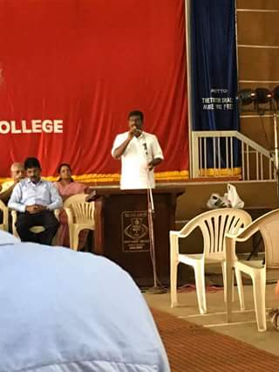

Sri. R. Rajesh, MLA of Mavelikara Constituency and Alumnus of Bishop Moore College, inaugurates the meet.

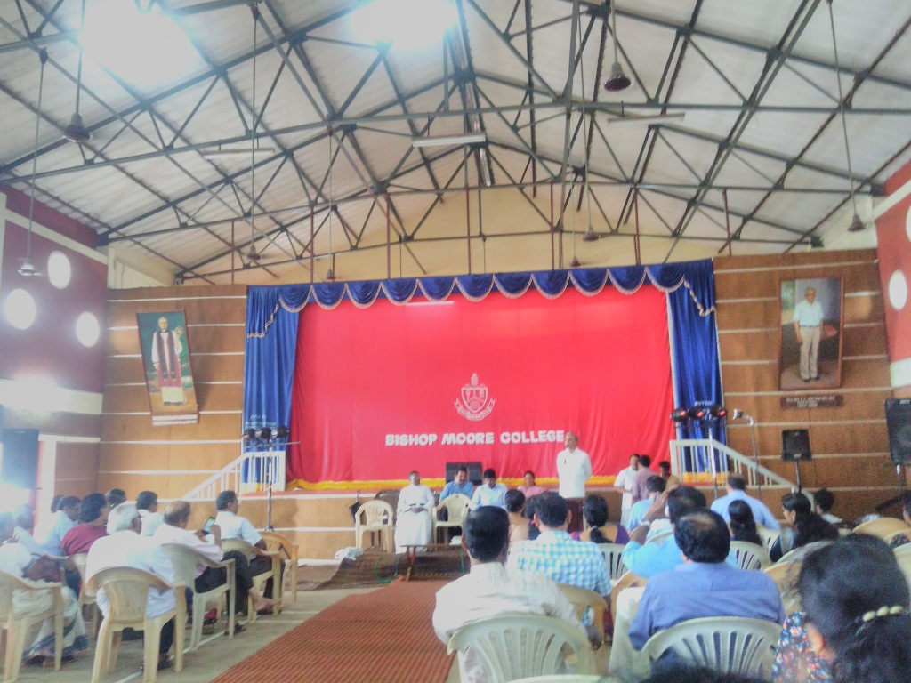

Prof. Mammen Varkey , Former Principal of the college

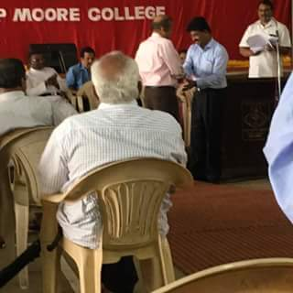

Principal, Dr. Jacob Chandy honours Prof. S. Parameswaran , retired professor of Mathematics

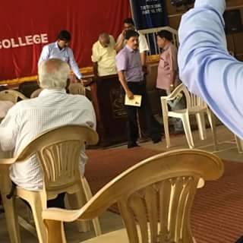

Prof. V. C. John, retired Professor of English hands over the publications by former students to Dr. Jacob Chandy

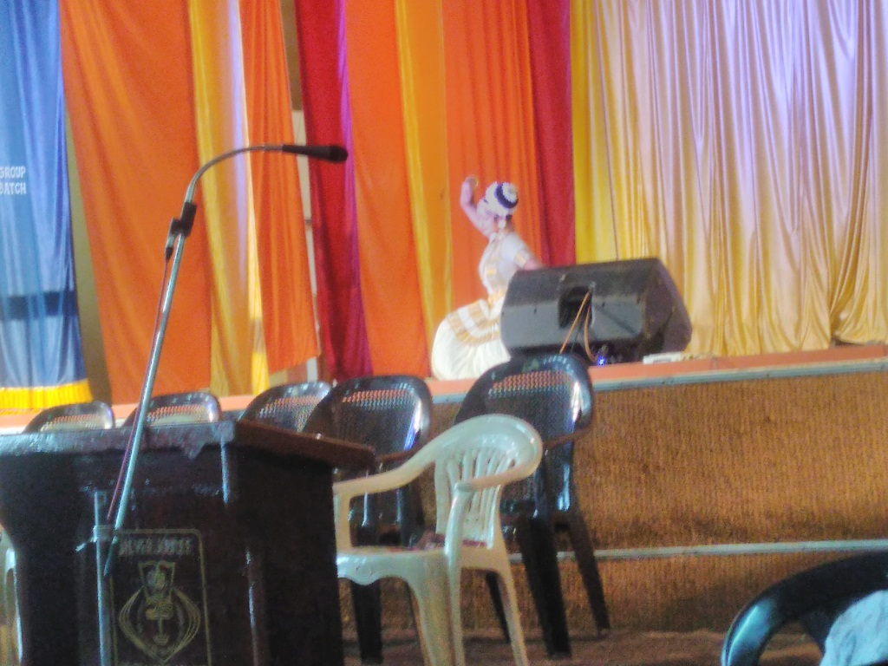

Mohiniyattom by Anjana , Alumnus of the college

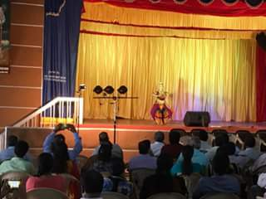

Bharatanatyam by Anju Sharath

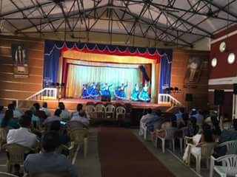

Group Dance by students

### Postal Address