Academic year 2017-18 begins: 01 June 2017

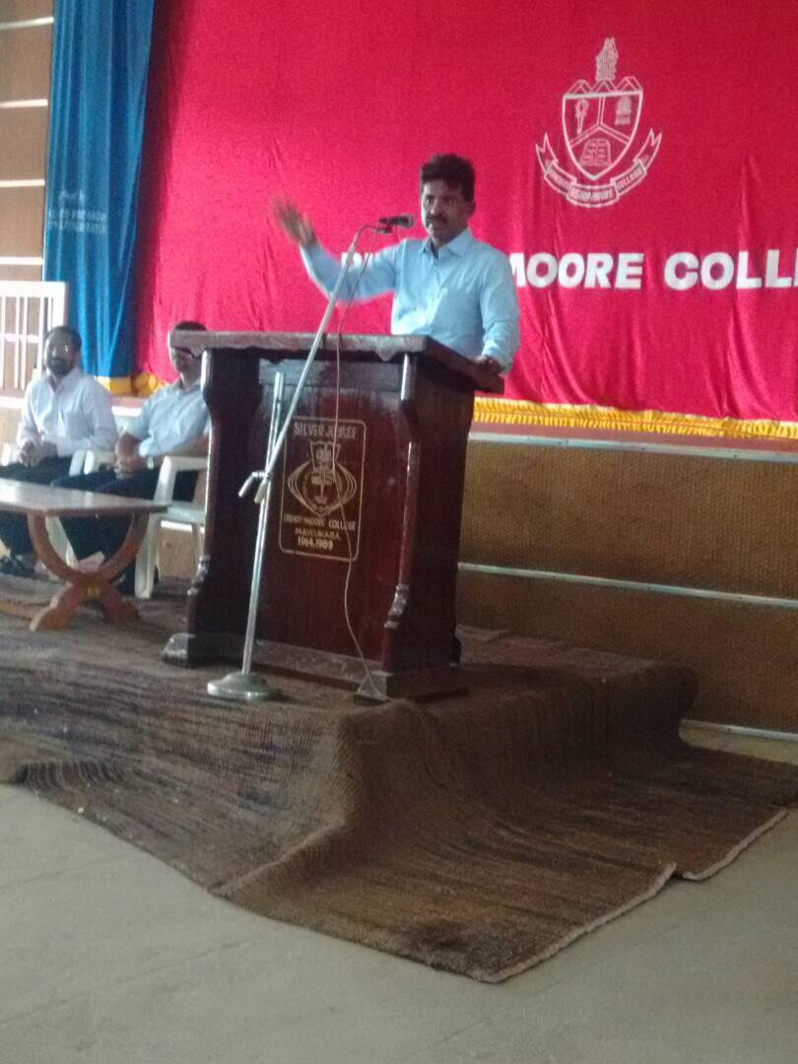

Principal, Dr. Jacob Chandy addresses the students

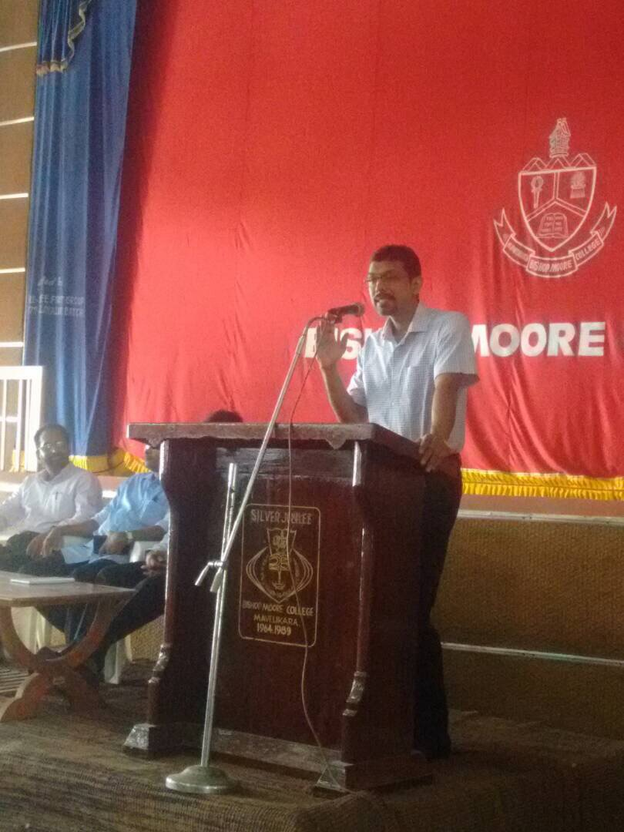

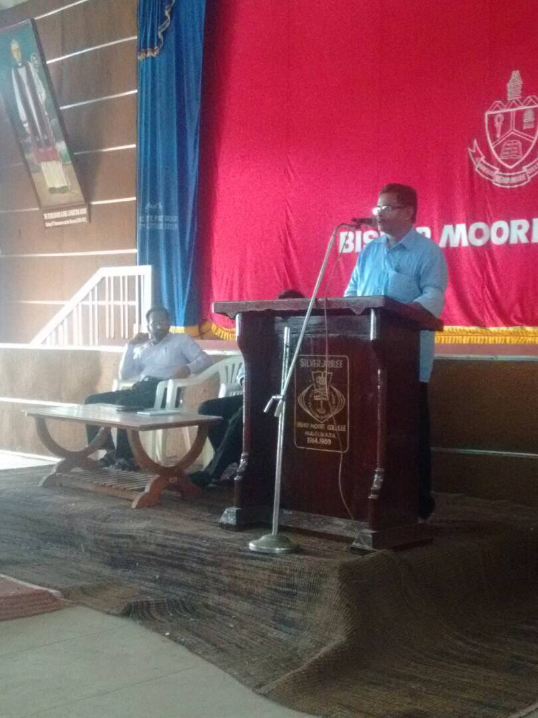

Prof. Johnson Chemmanam, HOD of Malayalam

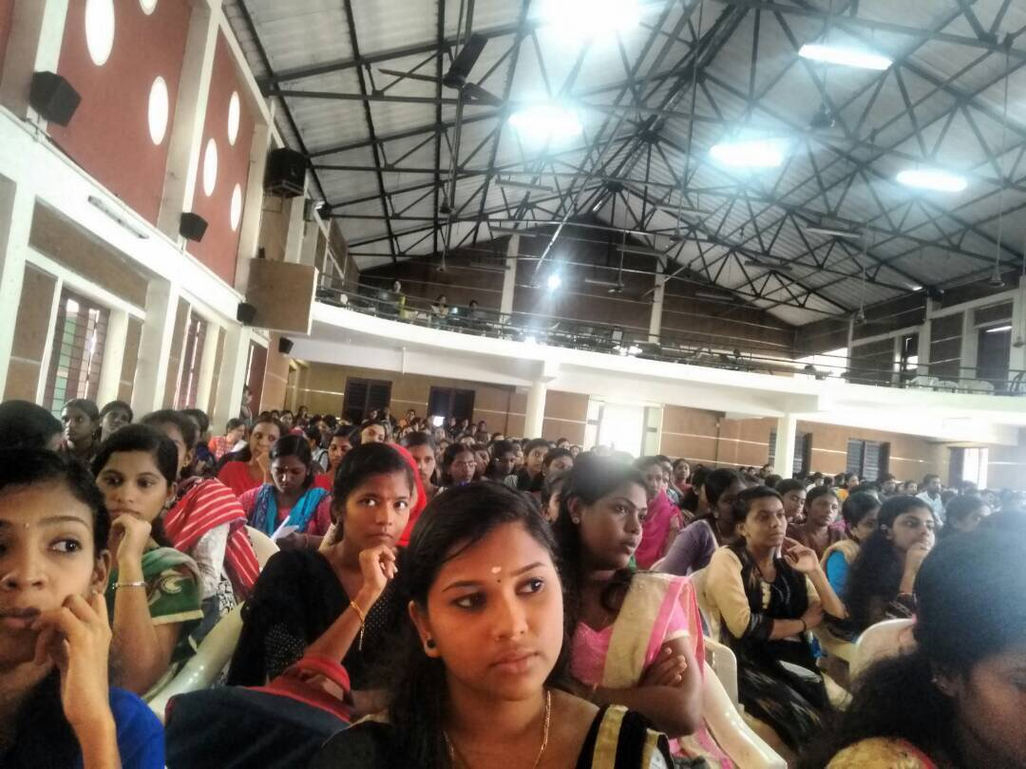

### Postal Address

Dr. Jacob Chandy