85th b’day of Kochamma of BMC Ladies’ Hostel: 25 June 2017

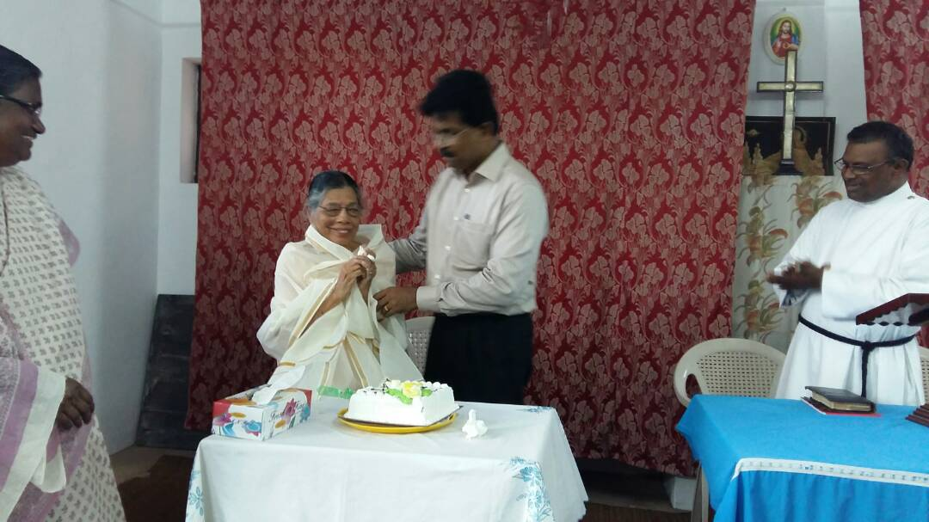

85th b'day of Kochamma of BMC Ladoes' Hostel

